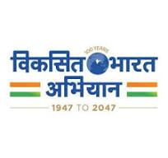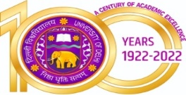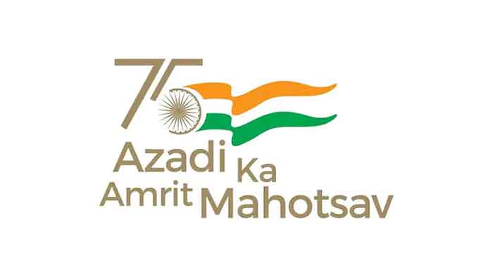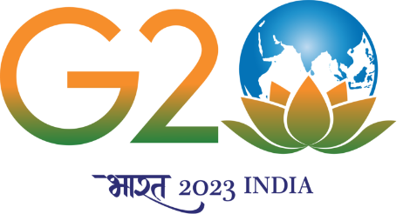

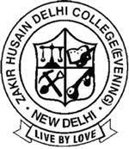

Annual Sports Report
2023-2024

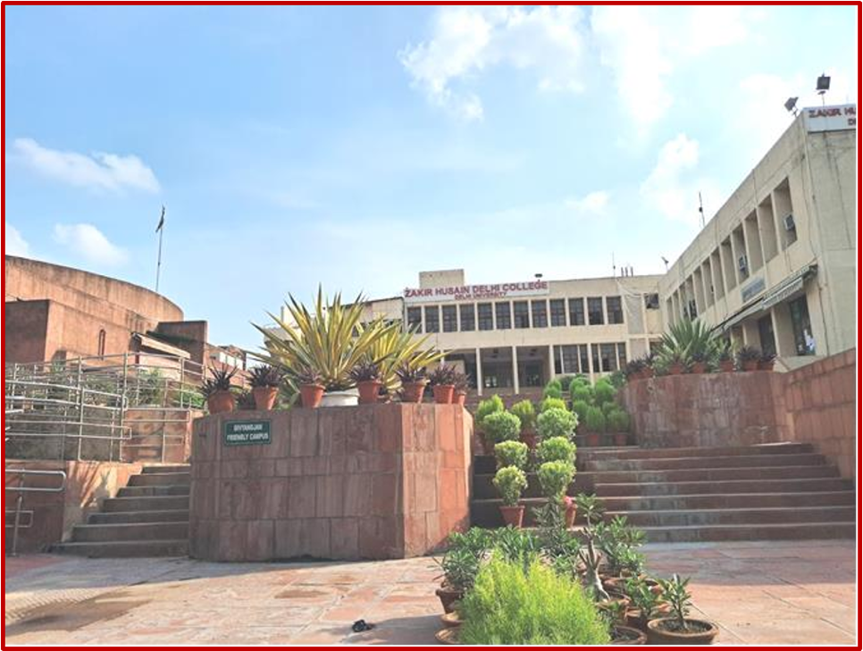

Zakir Husain Delhi College Evening
(University of Delhi)
Jawaharlal Nehru Marg
Delhi- 110002

Physical Education and Sports 2023-24

The academic year 2023-2024 at Zakir Husain Delhi College was characterized by a vibrant and dynamic sports culture, with students actively participating in various athletic events, tournaments, and recreational activities. The commitment of our college is to foster physical fitness, teamwork, and sportsmanship and it was evidently visible through numerous achievements and memorable moments on the field, court, and track. The annual sports report for the academic year 2023-2024 reflects an enduring dedication to promoting physical fitness, teamwork, and holistic development among its students. Through a diverse array of sports events, tournaments, and initiatives, the college has fostered a culture of sportsmanship, excellence, and inclusivity, enriching the lives of its students and contributing to their overall growth and well-being.
Here are some key points highlighting the importance of games and sports in academics:
Regular participation in games and sports promotes physical fitness and well-being. Engaging in physical activities helps in maintaining a healthy body weight, improving cardiovascular health, building muscle strength, and enhancing flexibility. A healthy body is essential for academic success as it ensures optimal brain function and cognitive abilities. Games and sports provide an outlet for stress relief and help in reducing anxiety and depression. Physical activity triggers the release of endorphins, neurotransmitters that promote feelings of happiness and relaxation. Students who participate in sports often exhibit better concentration, improved mood, and reduced symptoms of mental health disorders, which positively impacts their academic performance. Involvement in games and sports instills discipline and teaches students the value of time management. Athletes learn to balance their academic commitments with their training schedules, competitions, and other extracurricular activities. This ability to manage time efficiently translates into better study habits, increased productivity, and improved academic performance.
Many sports require collaboration and teamwork, fostering essential skills such as communication, cooperation, and leadership. Students learn to work harmoniously with their peers, respect diverse perspectives, and contribute towards common goals. These interpersonal skills are invaluable in academic settings, as they facilitate effective group projects, discussions, and classroom interactions. Athletes often set and strive towards achieving specific goals, whether it's improving their performance, winning competitions, or mastering new skills. This mindset of goal setting and perseverance transfers to academic pursuits, motivating students to set academic goals, overcome challenges, and persist in the face of obstacles. The resilience developed through sports enables students to bounce back from failures, learn from setbacks, and ultimately succeed in their academic endeavors. Engaging in physical activity has been linked to improved cognitive function, including better memory, concentration, and problem-solving abilities. Regular exercise increases blood flow to the brain, stimulates the growth of new neurons, and enhances synaptic plasticity, all of which contribute to enhanced learning and academic achievement.
Inter-College Tournaments:
The Students of our college showcased their talents and competitive spirit in inter-college tournaments across a spectrum of sports, including football, basketball, volleyball, cricket, and badminton.
Notable achievements were witnessed in a stupendous performance in the All Indian Enter-University Squash Tournament held in Mumbai and Greater Noida where our teams demonstrated exceptional skill, determination, and teamwork, clinching victories and earning recognition for the college.

Intramural Sports Events
The college organized a series of intramural sports events throughout the academic year, providing opportunities for students of all skill levels to participate and engage in friendly competition.
Events such as badminton witnessed an enthusiastic participation from students across various departments, promoting a bond in institutional space and healthy lifestyles.
Sports Tournament
Zakir Husain Delhi College hosted the 2nd Annual Begg Memorial Cricket Tournament on 27th and 28th March 2024 at NDMC Talkatora Cricket Ground drawing participation from students of three colleges of Delhi University. These colleges enthusiastically put their best cricketing skills on display during the matches. This tournament celebrated the spirit of sportsmanship and inclusivity, offering a platform for individuals to showcase their talents and passion for sports.
Sports encourage the integral components of a well-rounded education, offering numerous benefits that complement and enhance academic learning. By promoting physical health, mental well-being, discipline, teamwork, goal setting, cognitive function, and social development, sports contribute to the holistic development of students, preparing them for success both inside and outside the classroom.

Sports Registration for the Session 2023-2024

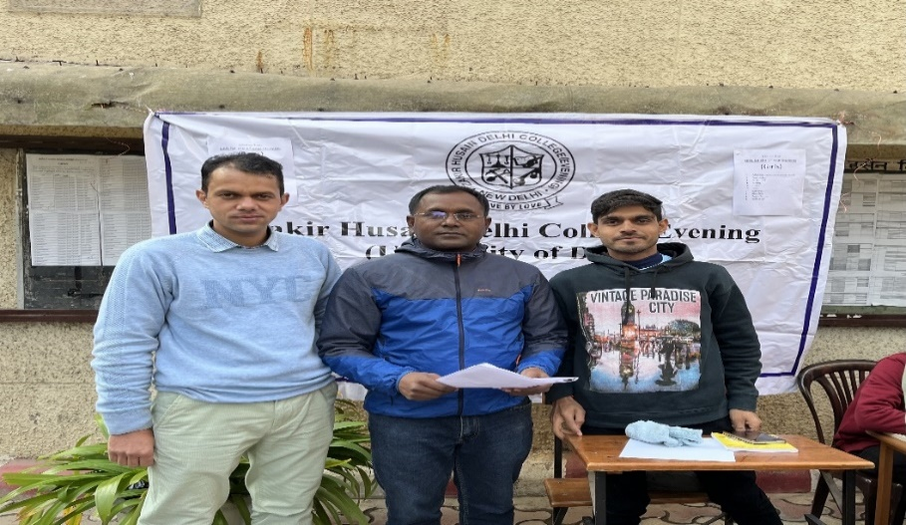
Faculty at Registration Desk 2023-2024
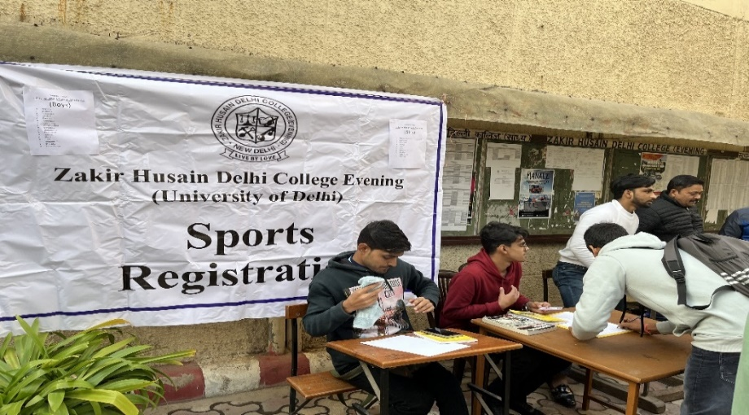
Registration for Selection Trails in the college premises

Participation in North Zone/Inter University and Delhi University Intercollege
Tournaments, 2023-24

Kabaddi (Men/Women)
Inter College, Selection Trials, Institutional Matches

Kabaddi is a dynamic and exciting sport that showcases athleticism, teamwork, and quick thinking. It has a rich cultural heritage and continues to evolve with modern adaptations and international competitions. The sports committee of Zakir Husain Delhi College has a passion to promote Kabaddi games and character building buy holding the sporting spirit.

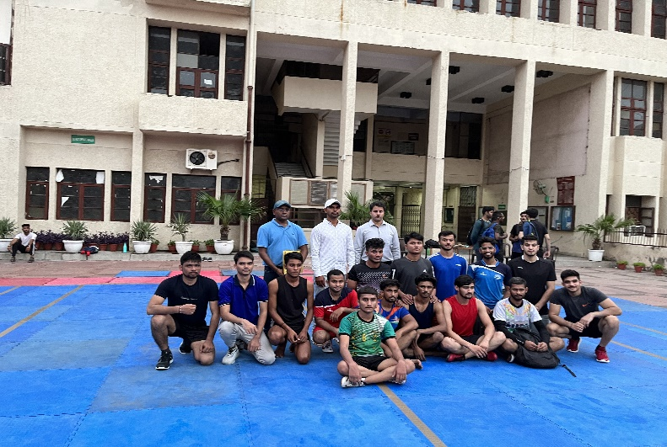
Kabaddi Trials at Zakir Husain Delhi College Evening

- The Kabddi Team of our college participated in Delhi University North Zone Kabaddi (Men) Selection Trials on 12.10.2023 at Shyam Lal College, University of Delhi.
- The Kabddi Team of our college participated in Delhi University Inter College Kabaddi Tournament held on 08.03.2024. The team played against Ramanujan College and performed well in the tournament.
- The team also participated in Spardha the Sports Festival of Amity University, Noida on 28.02.2024 and displayed their best Kabaddi skills and received applause by the audience.

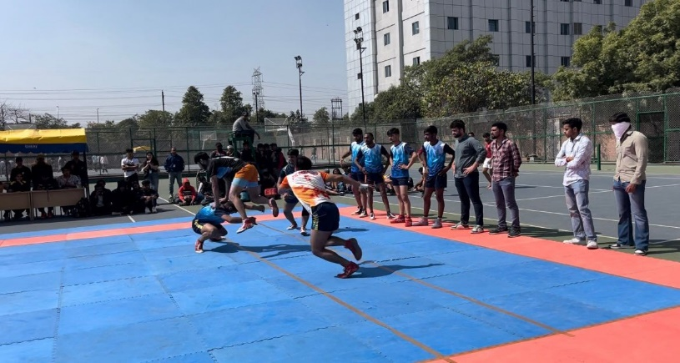
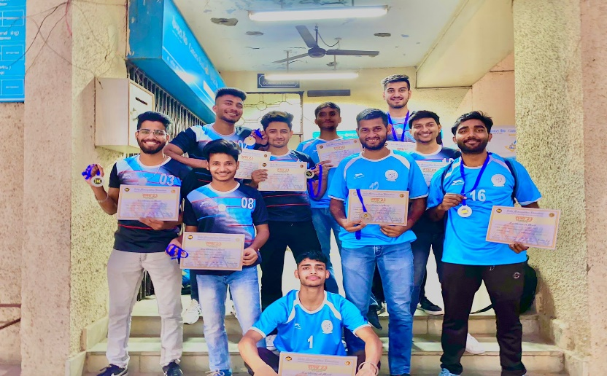
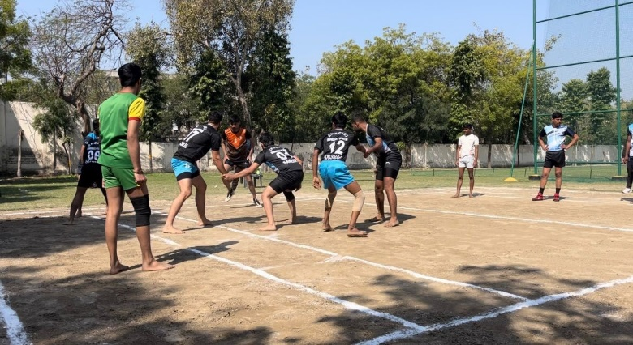
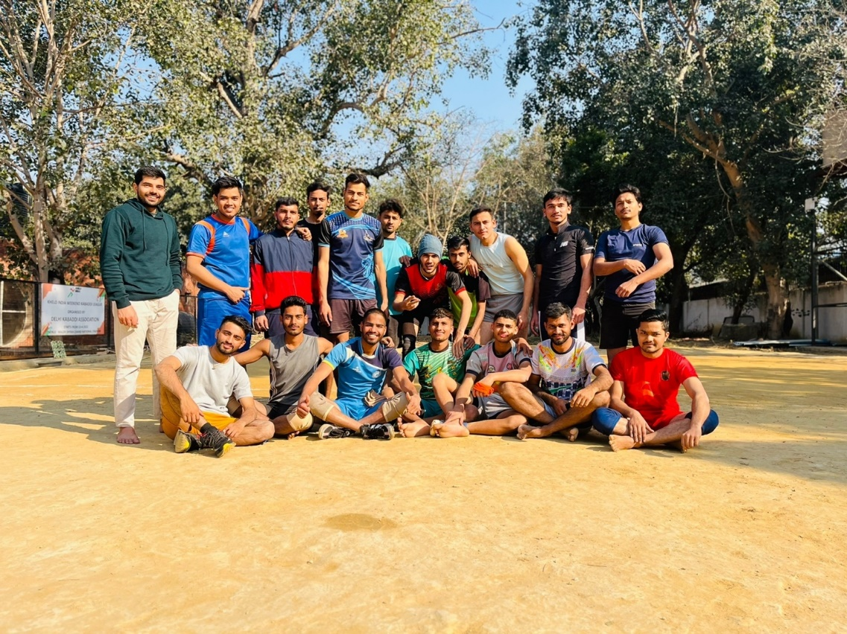
Post-practice Session at Major Dhyanchand National Stadium, Delhi

Cricket (Men)
Inter College, Selection Trials, Institutional Matches

Cricket is a popular sport played in many countries around the world. It is widely regarded as one of the most popular sports globally, with a massive following, especially in countries like India. Zakir Husain Delhi College Evening believes in character building by offering a platform to install values such as teamwork, leadership, resilience, discipline, sportsmanship, perseverance, and adaptability. These attributes not only contribute to success on the cricket field but also shape individuals into well-rounded and principled individuals off the field. During the session 2023-24, the sports committee of Zakir Husain Delhi College encouraged the cricket team to participate and put the sports skills on display in all the events of cricket contest.
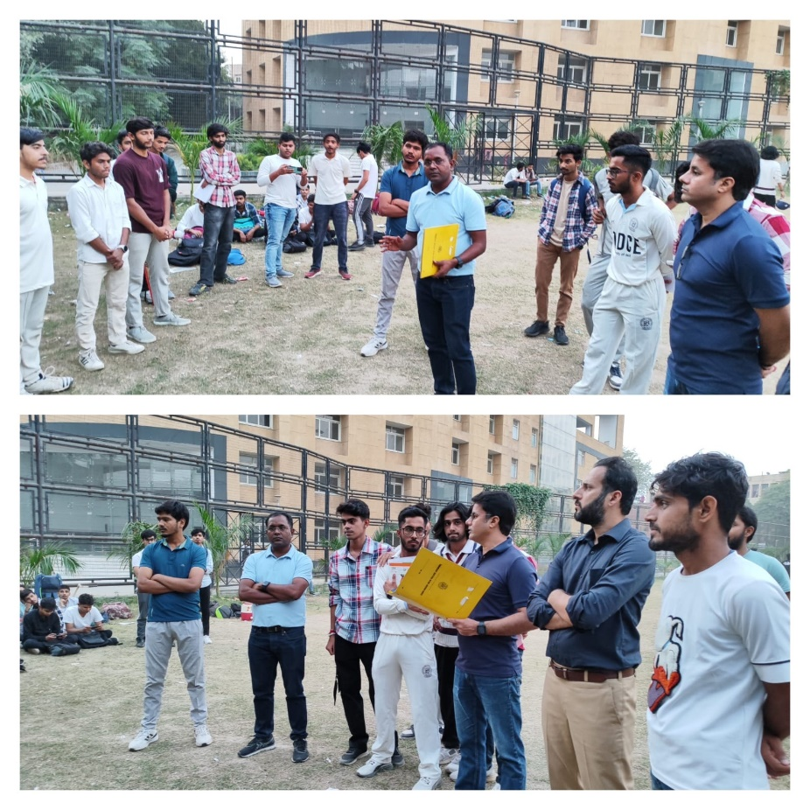
Selection Trials at Zakir Husain Delhi College Evening
- The cricket team selection trials for the session 2023-24 was held on 1st November, 2023 on the college cricket ground, and the students of first year were incorporated in the team.
- The college cricket team held practices matched in Noida for a better preparation to combat with inter college fixtures.
- Practice Session at Saket Sports Complex was also held on 16.11.2023 to immune the team spirit for upcoming tournament.
- The cricket team of the college held a practice session at Ramjas Sports Complex on 20.11.2023 for upcoming matches in the University of Delhi.
- The team enthusiastically participated in the Delhi University Inter College Tournament held on 21.11.2023. In the first match against Bhaskaracharya College of Applied Sciences, our team not only performed well but also won the match with a huge margin and ratio.
- The second match of the Intercollege Tournament was played on 23.11.2023 on the sports ground of DAV PG College against Bhim Rao Ambedkar College, University of Delhi in which our team displayed its best sports skills and received appreciation by the audience.

The 2nd M.M Begg Memorial Cricket Tournament, 2024

As an integral element of academic curriculum, sports activities have an essential value to nurture human personality. For promoting a culture of sports and games in the college with an objective to develop a philosophy of team spirit, physical fitness for a better coordination of mind, soul and body, our college has been sincerely engaged in encouraging the students to participate in sports activities with the available resources in the college. In order to excel and achieve the said objective, the sports committee of Zakir Husain Delhi College Evening organized the 2nd M.M. Begg Memorial Students’ Cricket Tournament on 27.03.2024 to 28.03.2024 at NDMC Talkatora Cricket Ground.

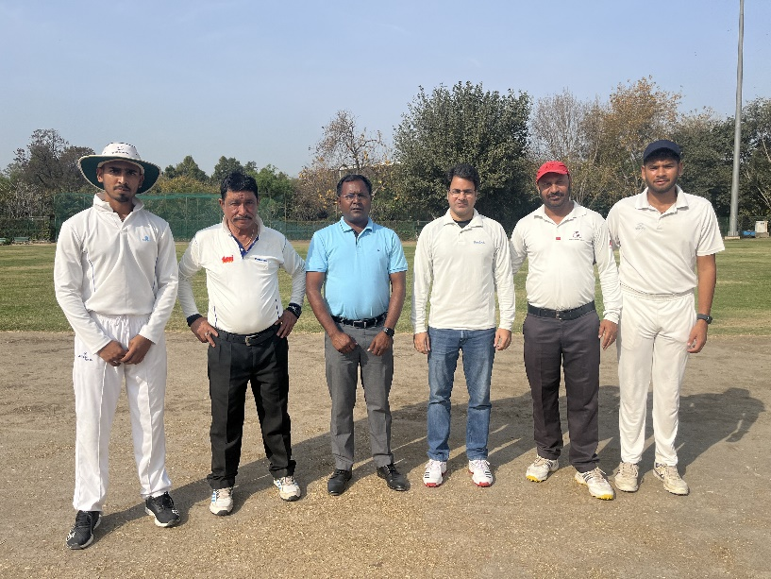
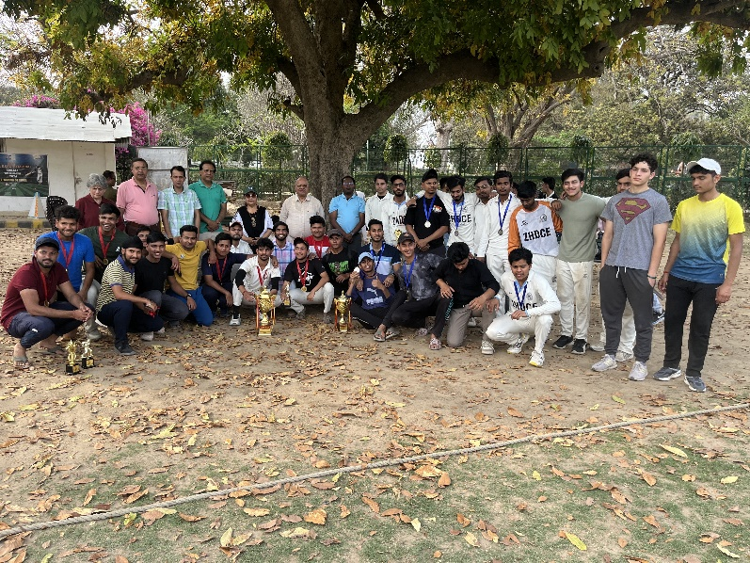
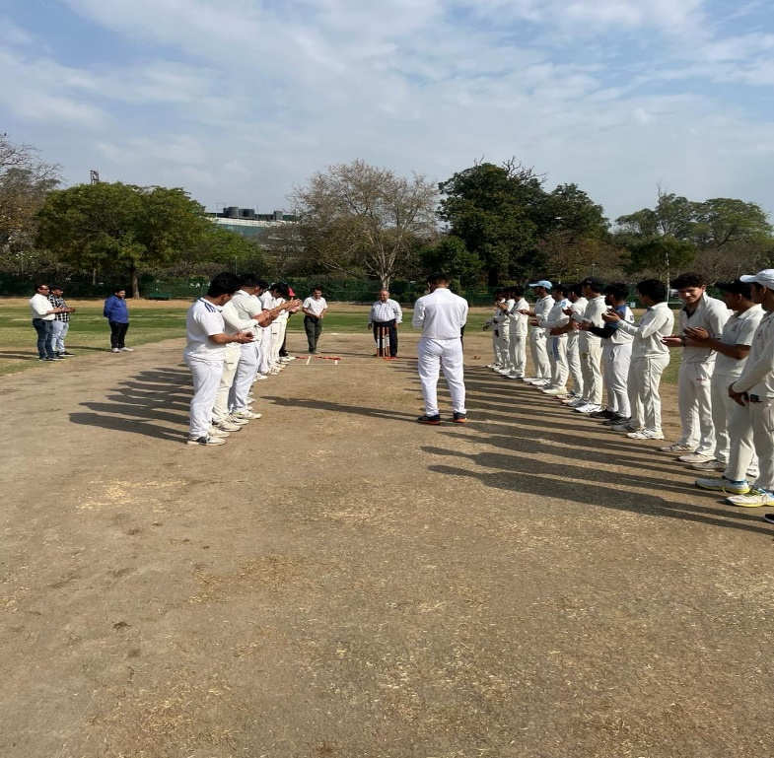
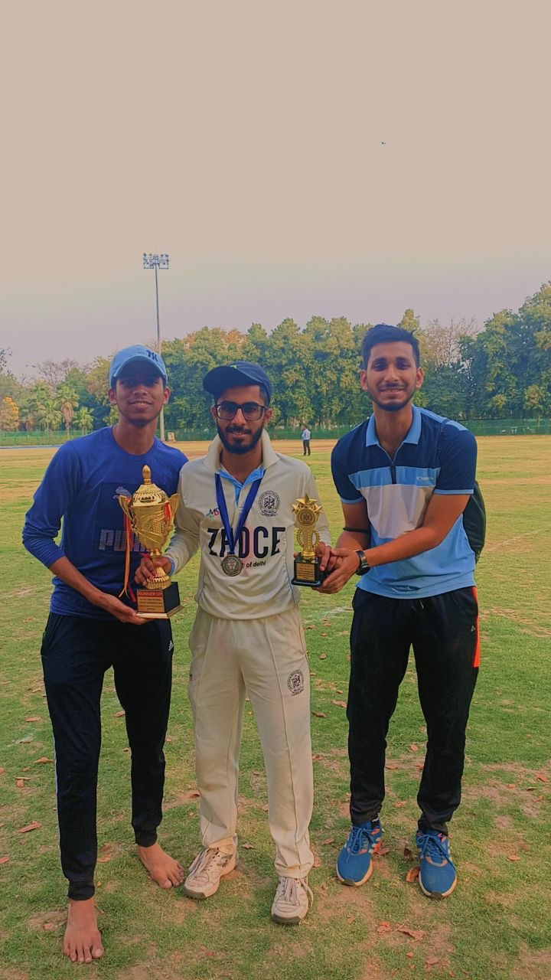

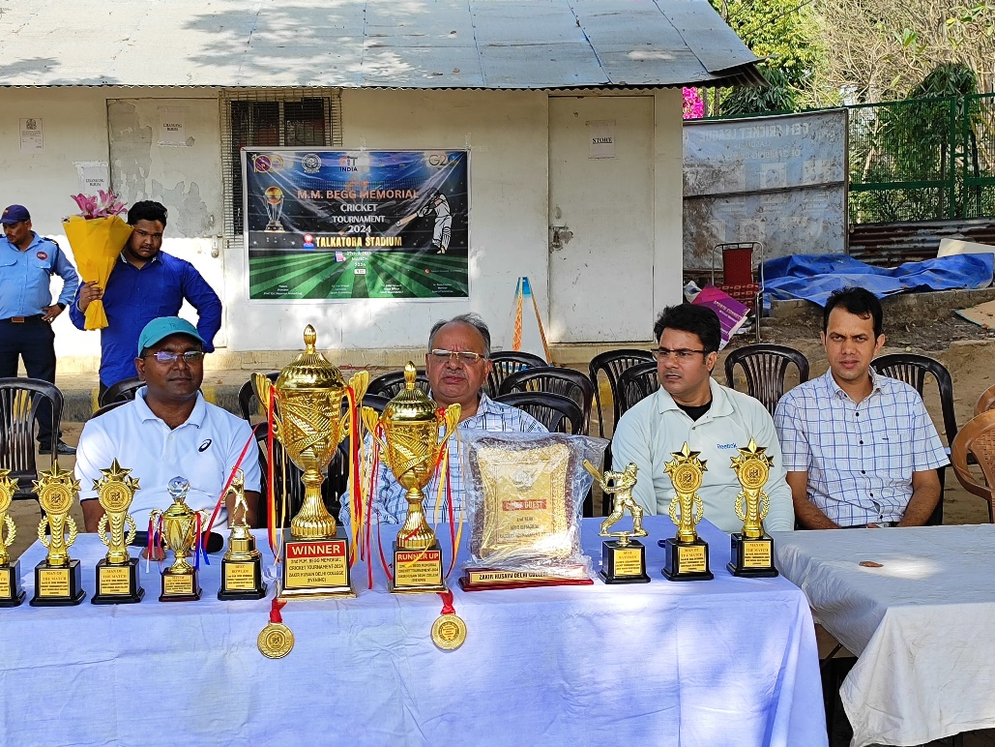

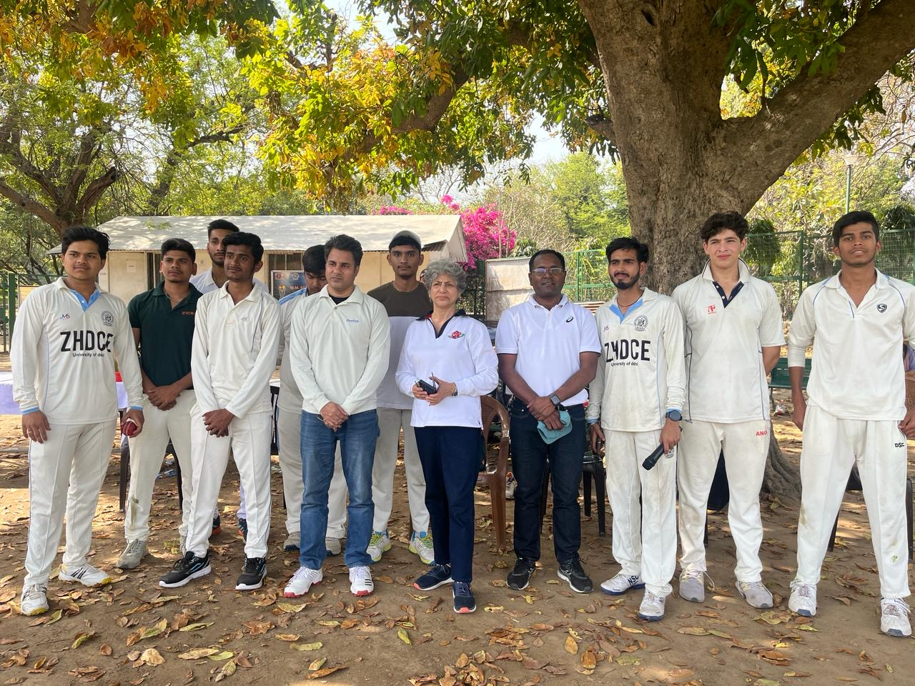

As an integral element of academic curriculum, sports activities have an essential value to nurture human personality. For promoting a culture of sports and games in the college with an objective to develop a philosophy of team spirit, physical fitness for a better coordination of mind, soul and body, our college has been sincerely engaged in encouraging the students to participate in sports activities with the available resources in the college. In order to excel and achieve the said objective, we are glad to inform you that the sports committee of Zakir Husain Delhi College Evening is organizing the 2nd M.M. Begg Memorial Students’ Cricket Tournament on 27.03.2024 to 28.03.2024.
The fixture of the tournament was well executed and all the matches were played in compliance with the ICC rules. The participation teams enthusiastically participated and gave their positive reviews about the arrangement and management of the entire functioning of the event.
The winner of the 2nd MM Beg Memorial Tournament was Maharaja Agrasen College, University of Delhi and the runner up trophy was picked by Zakir Husain Delhi College Evening.

The participating teams of the tournament were as follows:

- Maharaj Agrasen College, University of Delhi
- Bhaskaracharya College of Applied Sciences, University of Delhi
- Zakir Husain Delhi College University of Delhi
- Zakir Husain Delhi College Evening, University of Delhi

Judo (Women)
Inter College, Selection Trials, and Institutional Matches

Zakir Husain Delhi College Judo (Women) team has been active and participating in the intercollege Judo championship and Delhi Judo Association Tournaments. Our Student Ms Ankita Kumar has won Bronze medal in Delhi Olympic Judo association championship held in Delhi 2023-24.
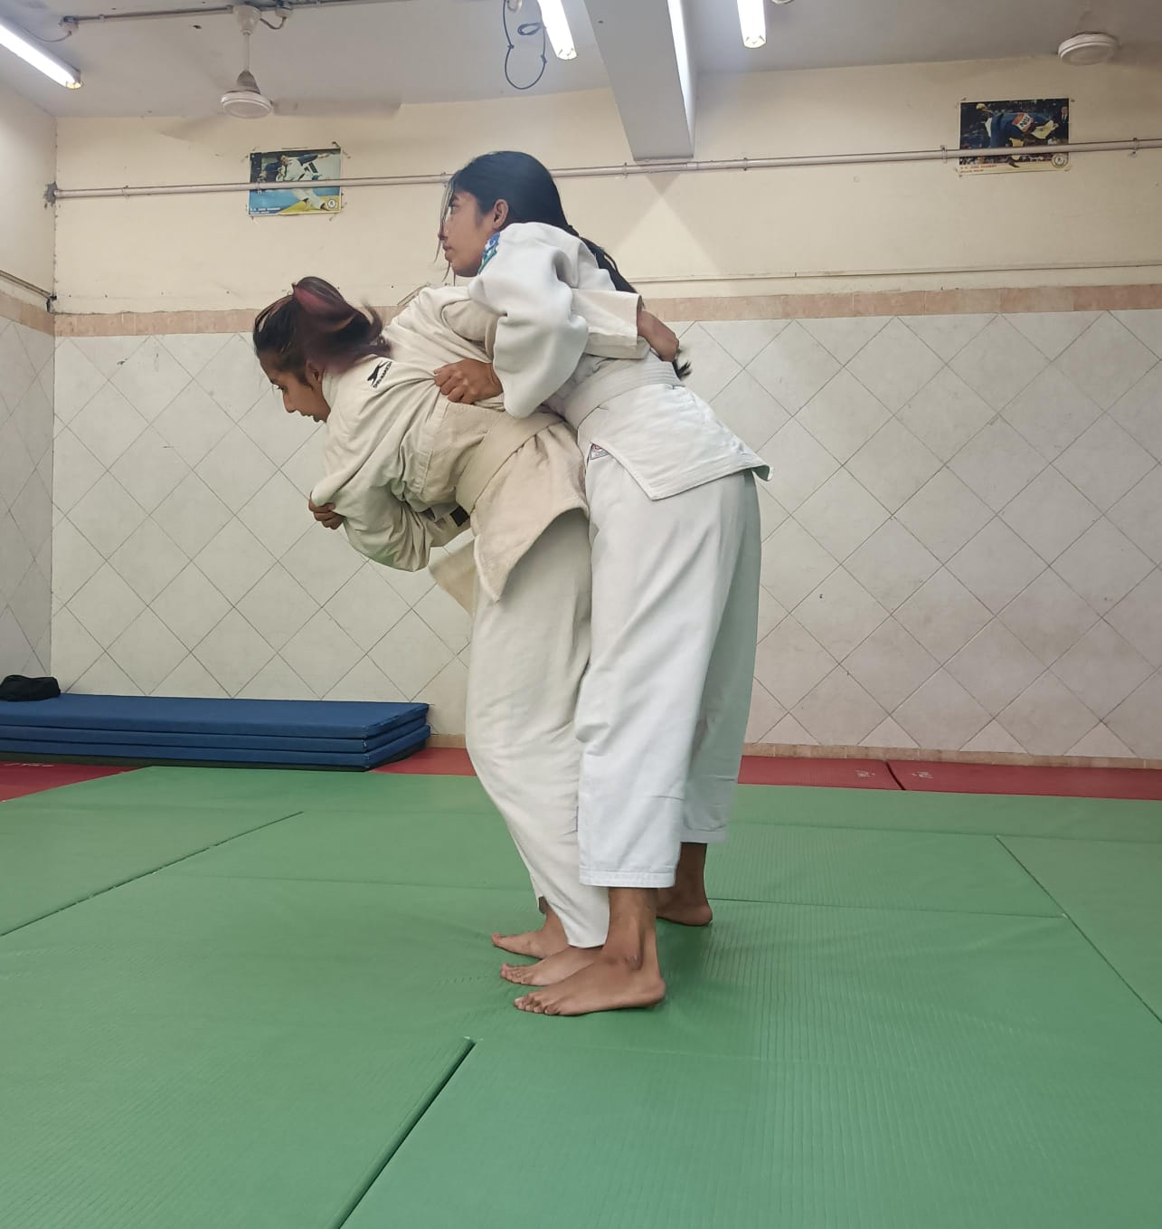
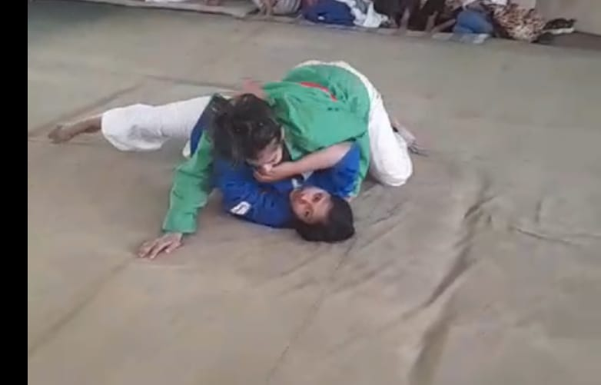
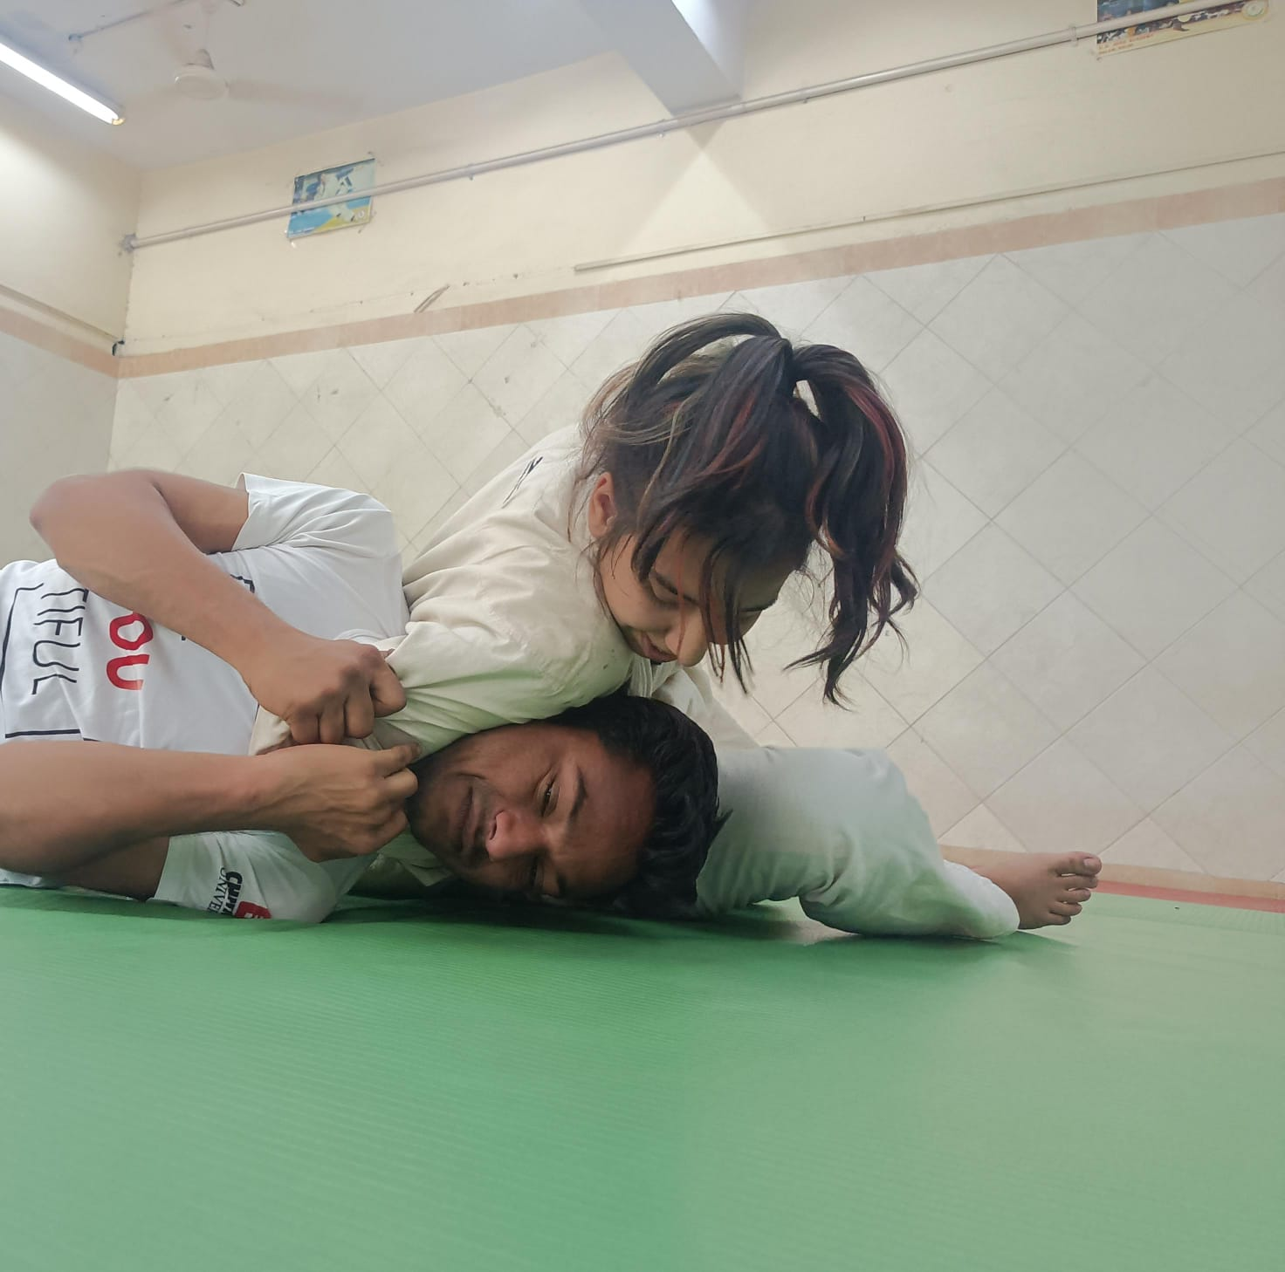
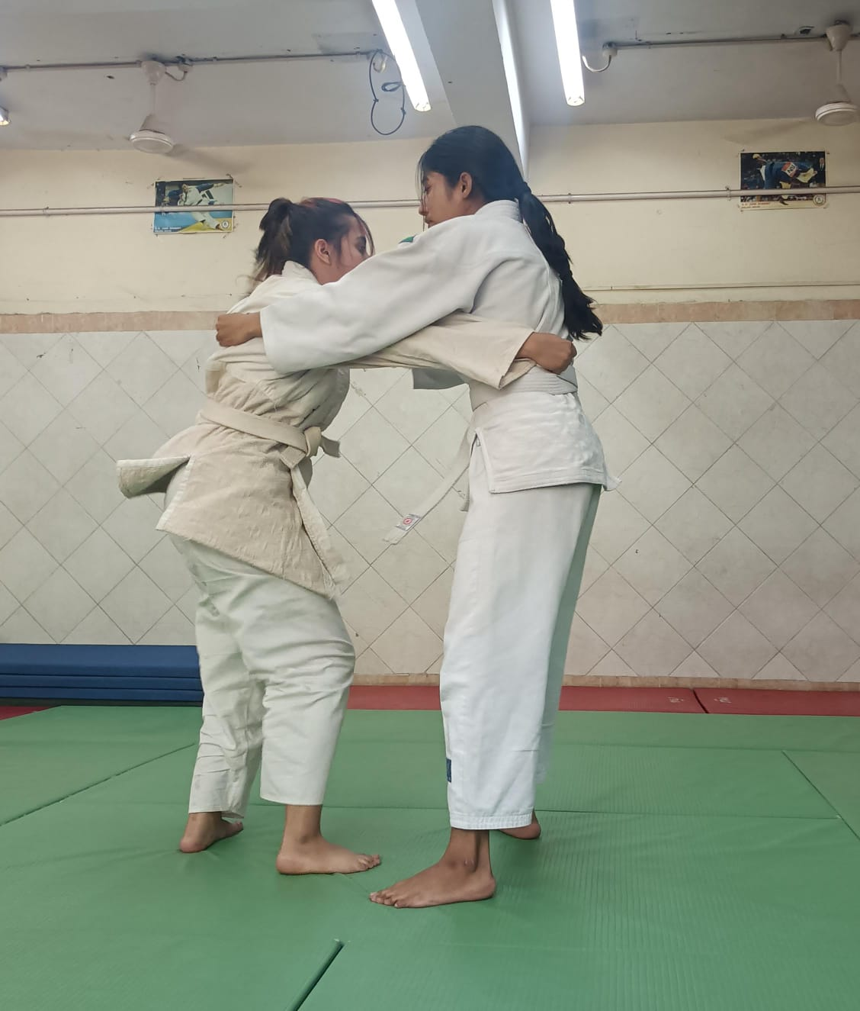
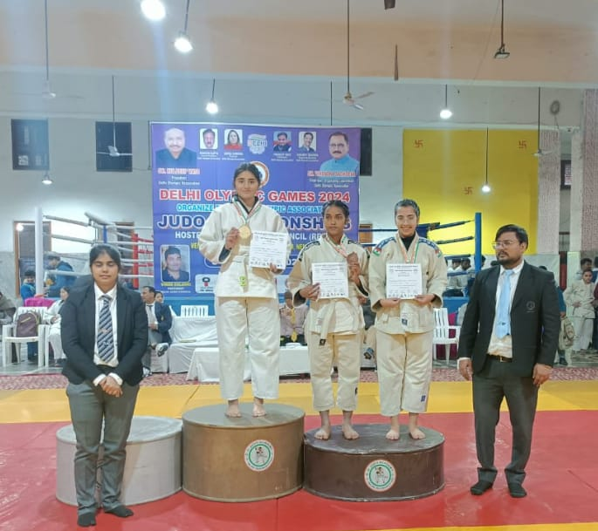
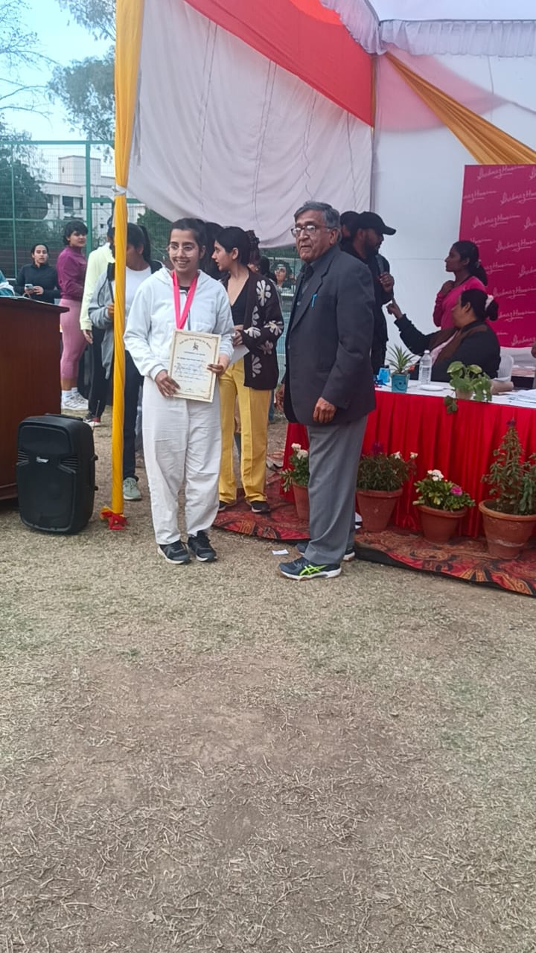
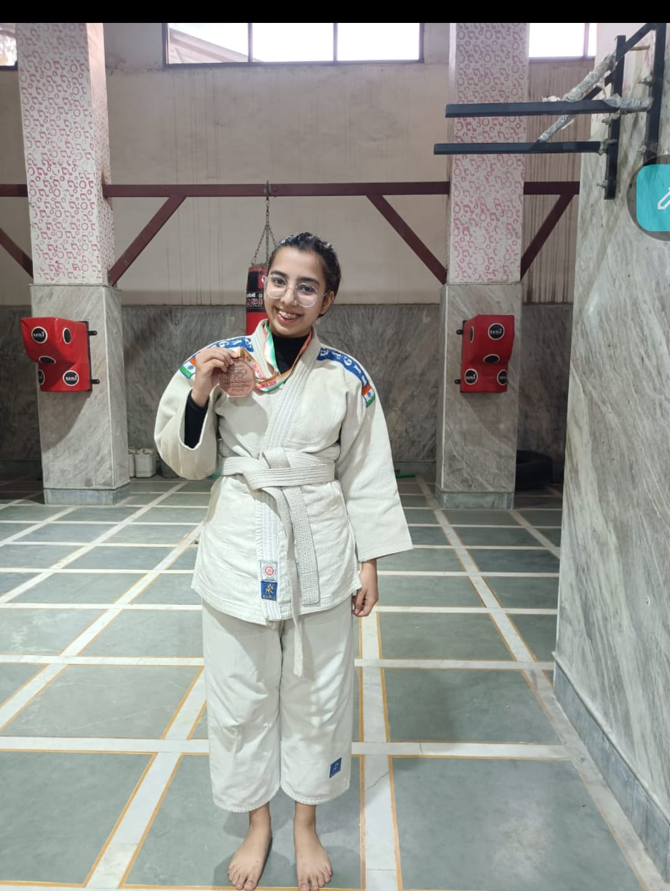

Football Report (Men)
2023-2024
Inter College, Selection Trials, and Institutional Matches

Zakir Husain Delhi College Evening has had a glorious history of football game. This game is a physically demanding sport that requires agility, endurance, and strength. Participating in football helps students stay active and promotes physical fitness, which is essential for overall health and well-being. Football relies on cooperation and coordination among players. Students learn to work together towards a common goal, communicate effectively, and support their teammates, fostering valuable teamwork skills that are applicable in various aspects of life. Within a football team, students have opportunities to take on leadership roles, such as team captain or positional leader. Leading and motivating teammates, making decisions under pressure, and taking responsibility for one's actions are all aspects of leadership that students can develop through football. Balancing academic responsibilities with football practice and games requires discipline and effective time management skills. Students involved in football learn to prioritize tasks, manage their schedules efficiently, and make sacrifices to excel both on the field and in the classroom.

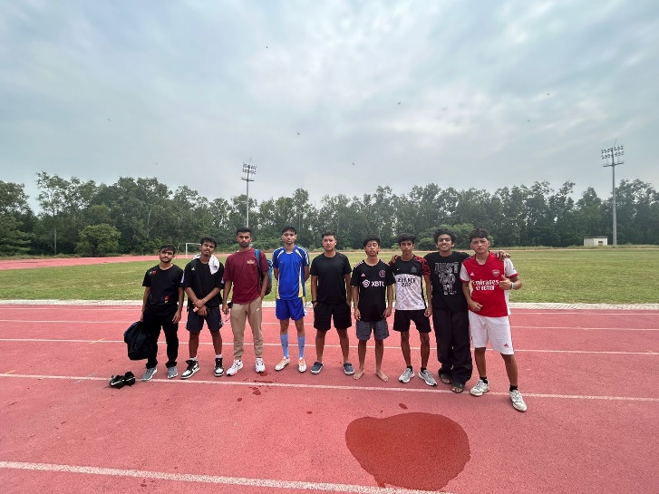
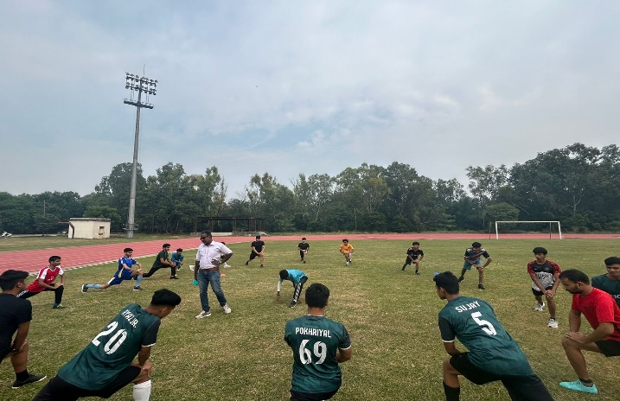
Practice Session at Polo Ground, University of Delhi

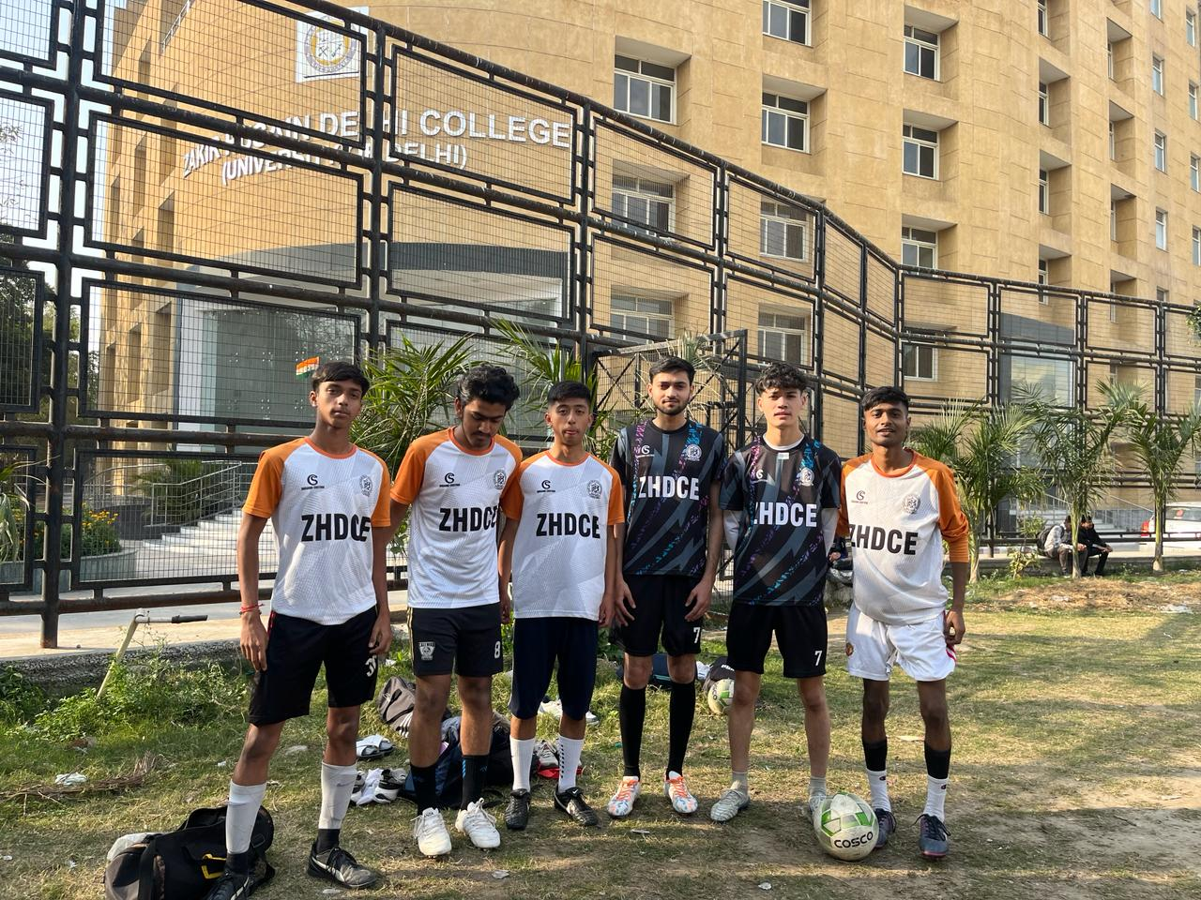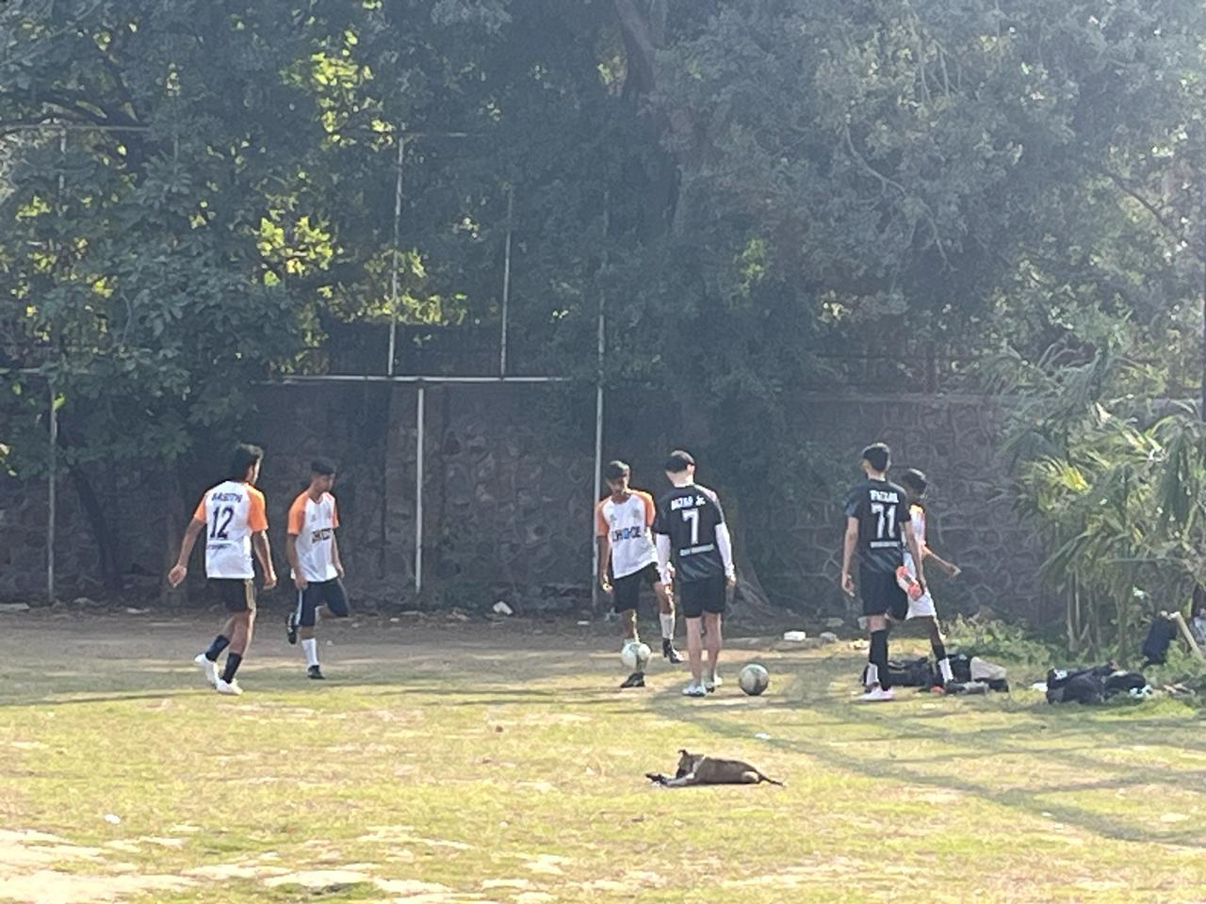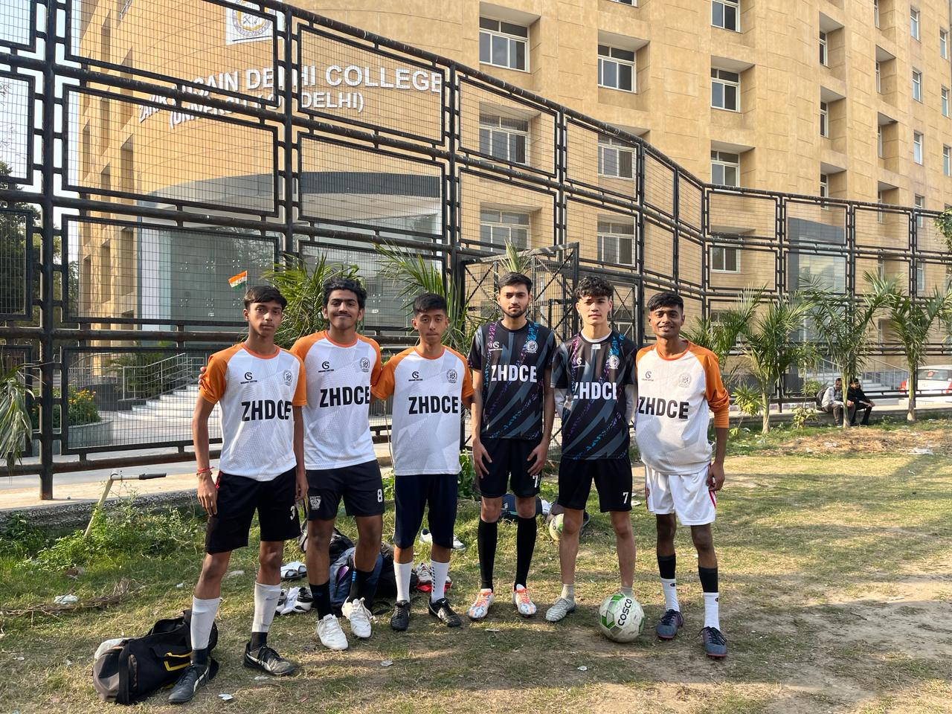

Regardless of differences in language, ethnicity, or socio-economic status, students can bond over their shared passion for the sport, fostering friendships and building a sense of community. Mastering new techniques, scoring goals, and contributing to team victories can install a sense of pride and accomplishment in students. Zakir Husain Delhi College Evening has been sincerely encouraging the students to develop the said skills and enhance the range of physical, social, and personal benefits, contributing to their holistic development and enriching their educational experience.

In the selection trials, the following members were added as the team members.
- Faizal Khan
- Al Basith
- Jigmet Naro
- Aman Raj
- Srijan Srivastava
- Ayan Gupta
- Jigmet Dorjey

- Our team participated in Delhi University Inter College football tournament held on 03.11.2023 and played against Maharaja Agrasen College, University of Delhi. The football team has regularly on practice at Polo Ground, University of Delhi for the sports events and players’ physical fitness.

Badminton (Men/Women)

Inter College, Selection Trials, Institutional Matches

Badminton provides an excellent cardiovascular workout, helping students maintain or improve their physical health. It enhances agility, speed, hand-eye coordination, and overall fitness levels, promoting an active lifestyle among college students. Engaging in badminton serves as a stress reliever for college students, offering a break from academic pressures and a chance to unwind. Physical activity releases endorphins, which can help reduce stress, anxiety, and depression, contributing to better mental health. Badminton fosters social interaction and teamwork, as it often involves playing with partners or in teams. Zakir Husain Delhi College Evening badminton teams provide students with opportunities to meet new people, make friends, and build social connections with peers who share similar interests. It allows students to develop various skills, including technical skills such as racket handling, shot accuracy, and footwork, as well as non-technical skills such as communication, sportsmanship, and leadership. ZHDCE Intramural or intercollegiate badminton tournaments provide students with opportunities to compete at various skill levels. These events promote healthy competition, teamwork, and sportsmanship while offering recreational opportunities for students who enjoy playing badminton casually.
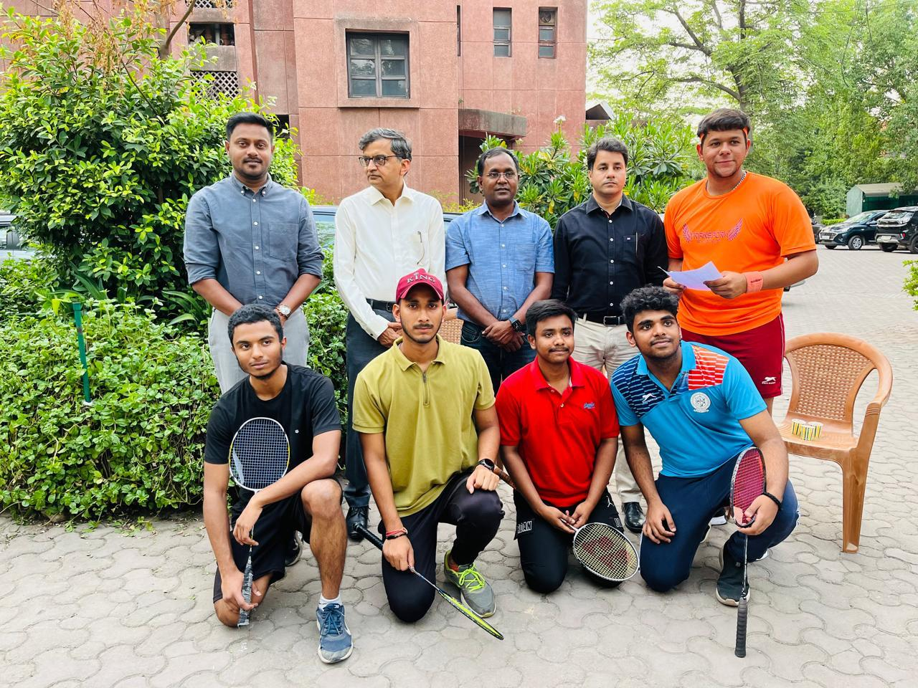
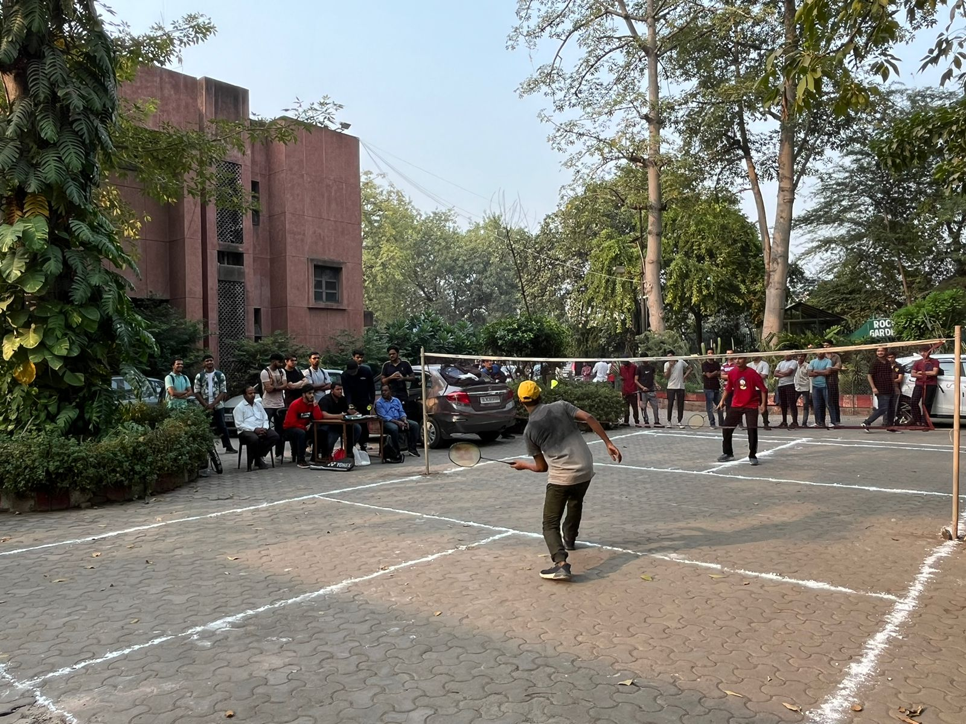
- Selection trials were held in the college to prepare the official team of the college for representing the team in the Inter College as well as other sports events for the session 2023-2024.
- Team participated in the Inter College Tournament Badminton tournament organised by the Delhi University Sport Council on 03.03.2024 at the Multipurpose Hall, University of Delhi.
- The girls’ badminton team also participated in the Inter College badminton championship held on 12.03.2024 organised by the Delhi University Sports Council at the Multipurpose Hall, University of Delhi.
Volleyball (Men/Women)
Inter College, Selection Trials, Institutional Matches

Volleyball plays a vital role in the holistic development of student-athletes, providing them with opportunities for athletic achievement, personal growth, and community engagement. Additionally, successful volleyball programs can enhance the reputation and visibility of college institutions, attracting talented athletes and fostering a sense of pride among students, alumni, and fans.
By implementing the said credo, Zakir Husain Delhi College Evening encouraged its students to participate in various volleyball sports events which may include Intercollege championship, Inter University Selection Trials conducted by the Delhi University Sports Council during the year 2023-2024. College volleyball provides student-athletes with opportunities to enhance their athletic abilities. Through rigorous training programs, players improve their skills in areas such as serving, passing, setting, spiking, and blocking. This development not only benefits the individual players but also contributes to the overall competitiveness of the team.
- The college Volleyball team participated in the Inter college volleyball championship held on 16.02.2024 against PGDAV at Kehav Mahavidyalaya, University of Delhi.
- 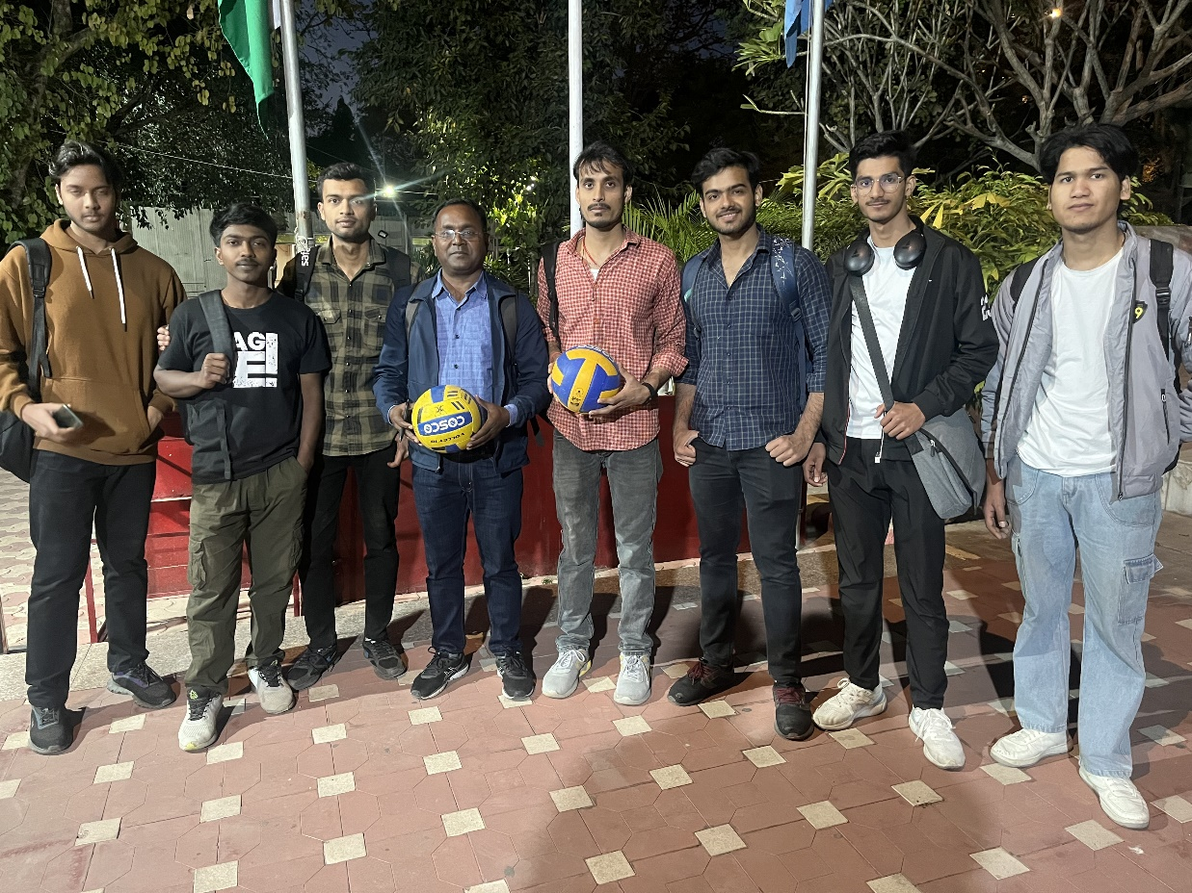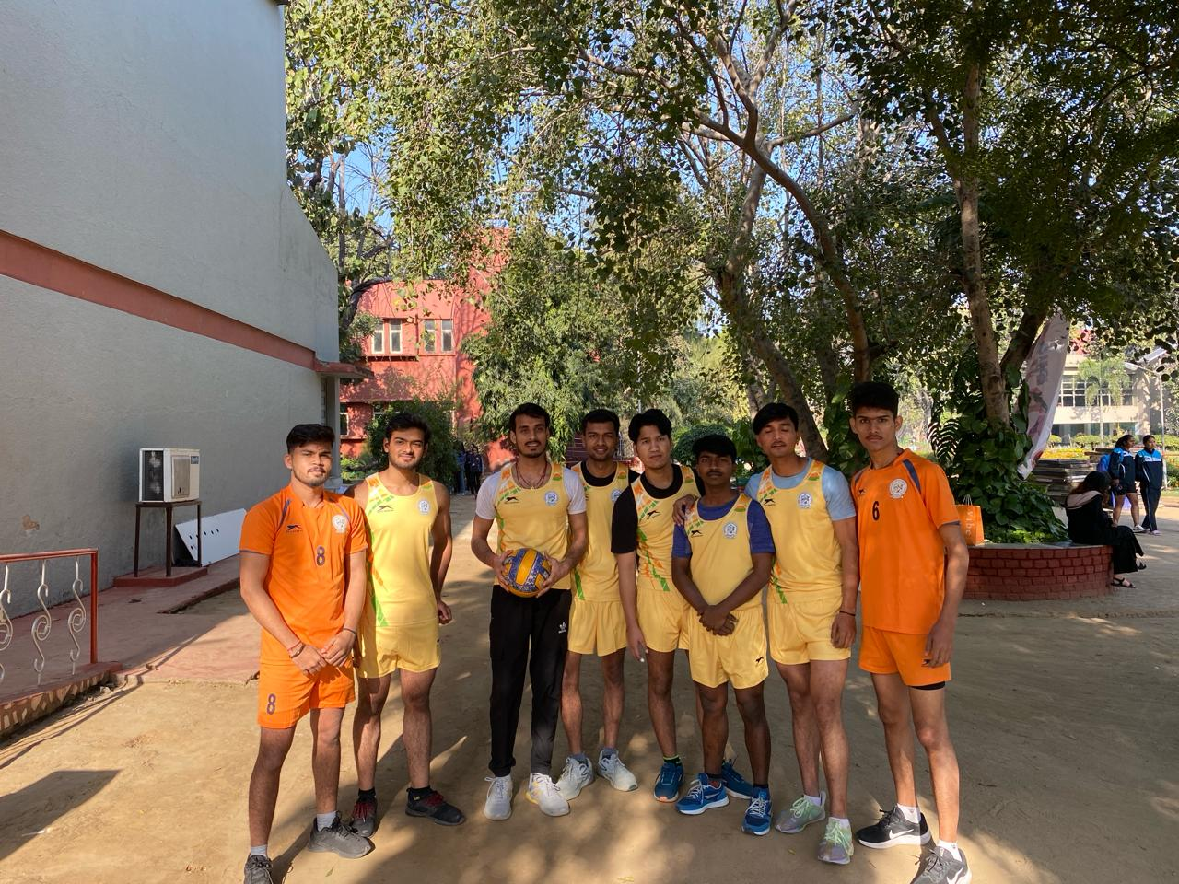
College Team participating in Delhi University Inter College Volleyball Tournament 2023-24

Basketball (Men)

Inter College, Selection Trials, Institutional Matches

Like volleyball, basketball provides a platform for athletes to develop their skills. Players hone their abilities in shooting, dribbling, passing, and defending through rigorous training and competitive gameplay. Participating in college basketball helps athletes maintain peak physical fitness levels, promoting overall health and well-being. Similar to volleyball, basketball emphasizes teamwork and collaboration. Players learn to communicate effectively, trust their teammates, and work towards common goals. Leadership opportunities often arise within basketball teams, allowing players to develop valuable leadership skills that are applicable both on and off the court. Balancing academic commitments with the demands of basketball requires strong time management skills and discipline. Our students have learnt to manage their schedules to excel both academically and athletically.
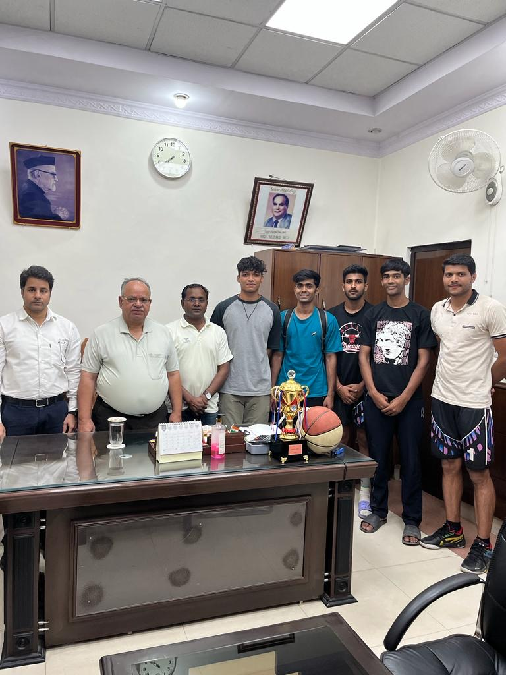

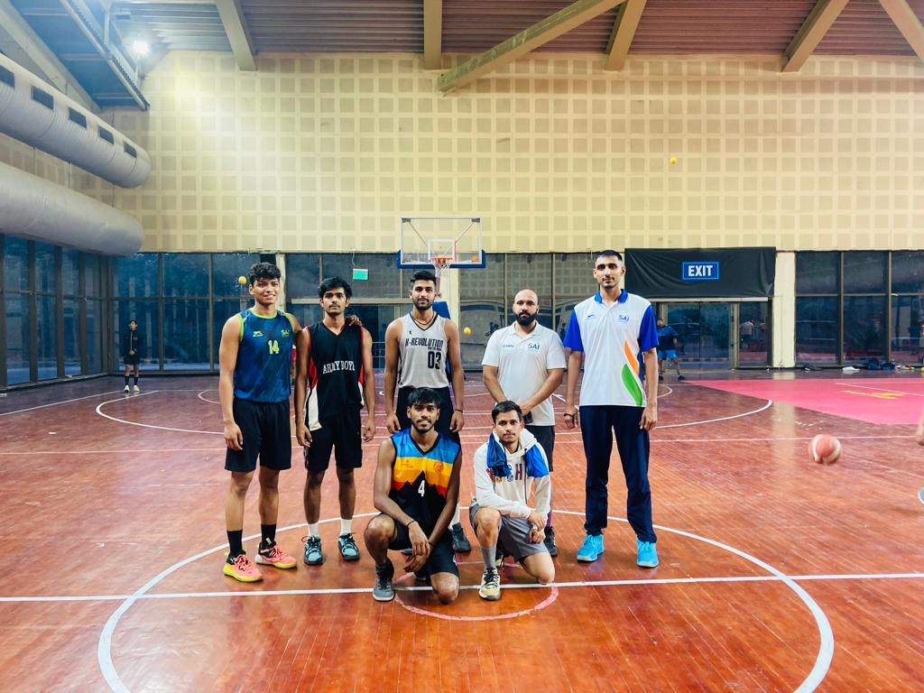
Through the challenges experienced on the court, players learn resilience, perseverance, and how to handle pressure in high-stakes situations. These experiences contribute to the holistic development of student-athletes, helping them become well-rounded individuals. Additionally, basketball programs frequently engage in community service initiatives, allowing players to give back to their communities and make a positive impact beyond the basketball court.
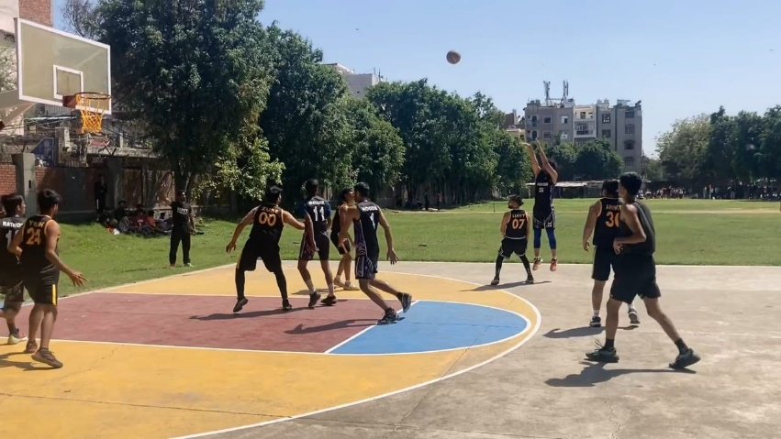

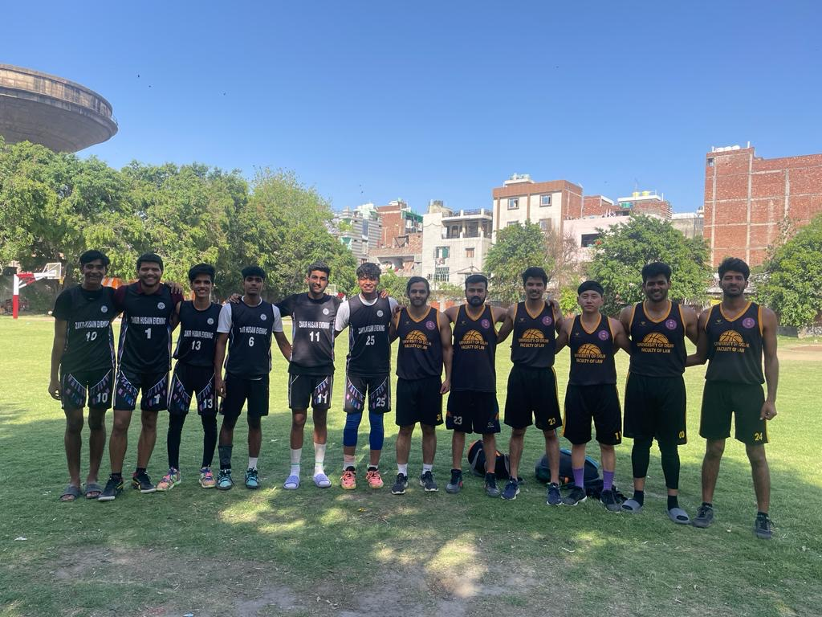
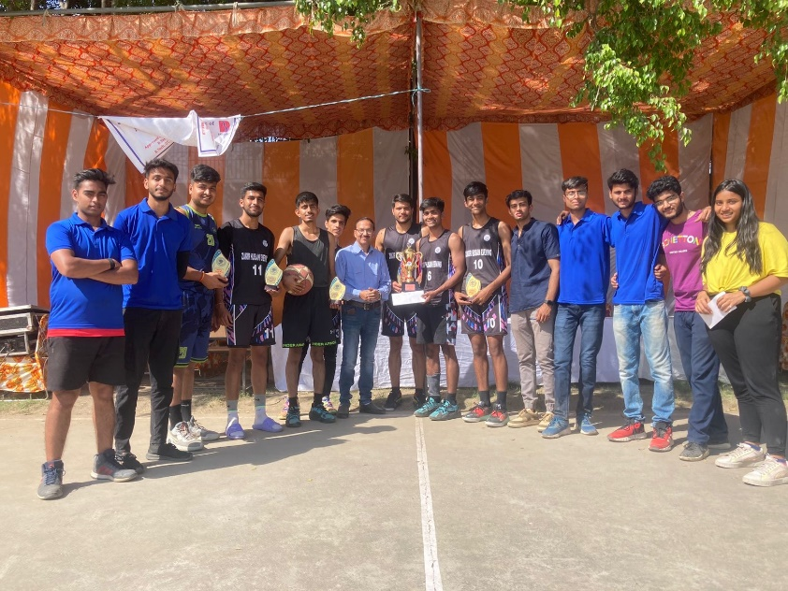
- The team participated in the inter college championship organised by the Delhi University Sports Council on 27th February, 2024 at Hindu College, University of Delhi.
- Our team participated in ADGIPS Sports events and displayed the sports skills in the tournament.
- Participated in LSR sports meet and performed well in the match.

Air Rifle Shooting (Men)
Inter College, Selection Trials, Institutional Matches

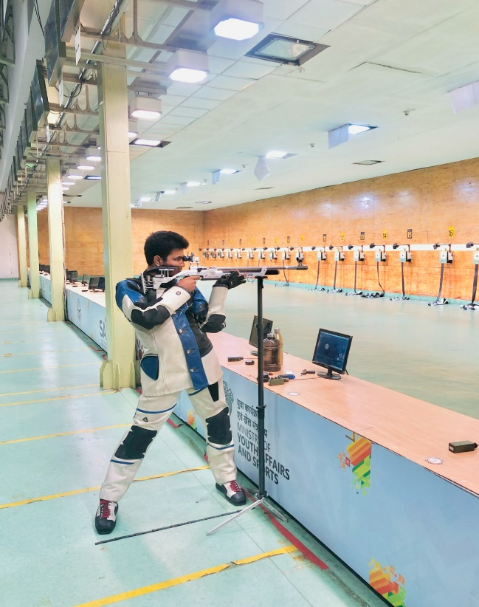
Practice at Shooting Studio

Air rifle shooting is indeed recognized as a sport in many colleges and universities around the world. University of Delhi also invites its students to participate in Inter College Tournaments, Selection Trials and Interuniversity Championships. Zakir Husain Delhi College Evening enthusiastically sent an outstanding player for the said contests. Our students Arpit Kumar brought laurel to our college as well secured a place for Inter University Games, Khelo India sports events.
Mr Arpit Kumar secured the following position in the various national, university level sports events:
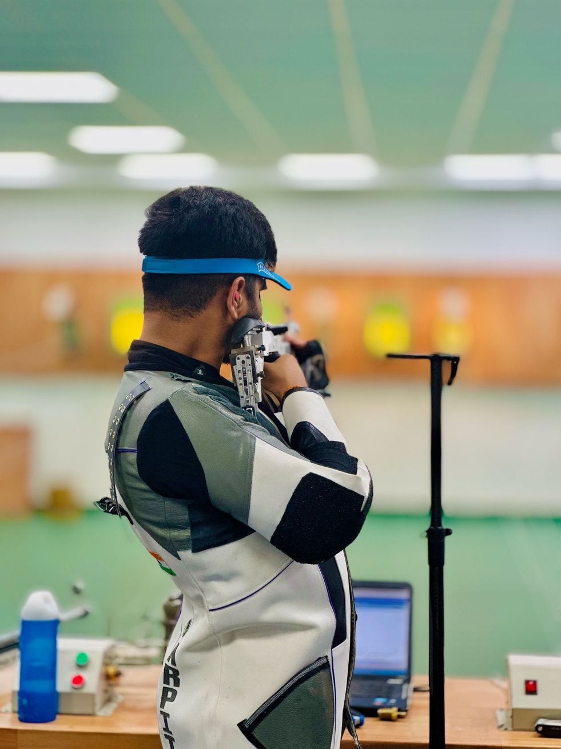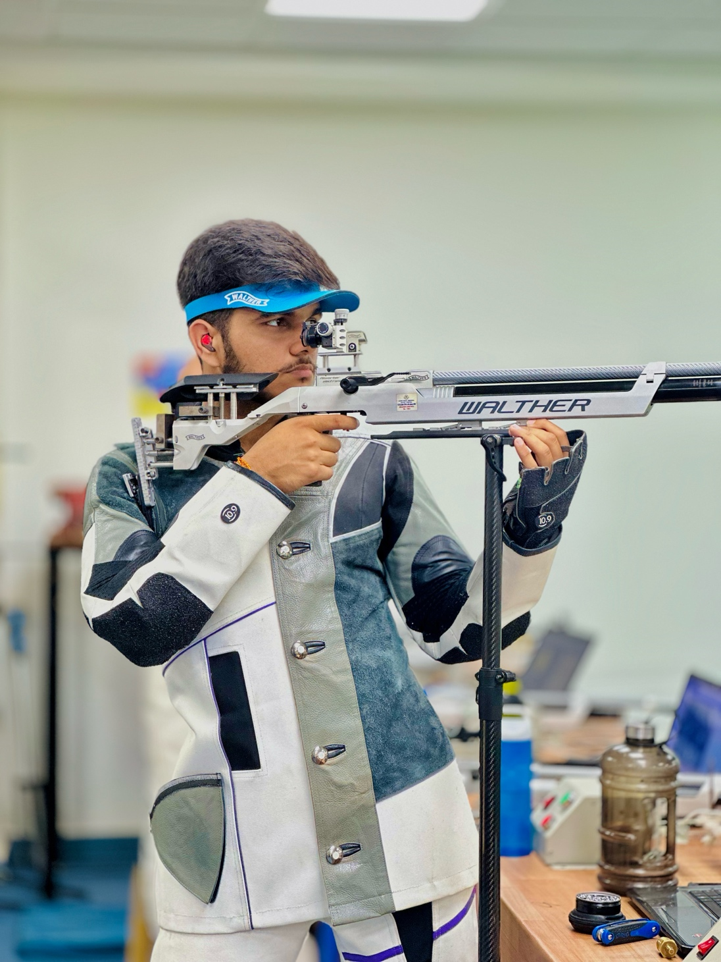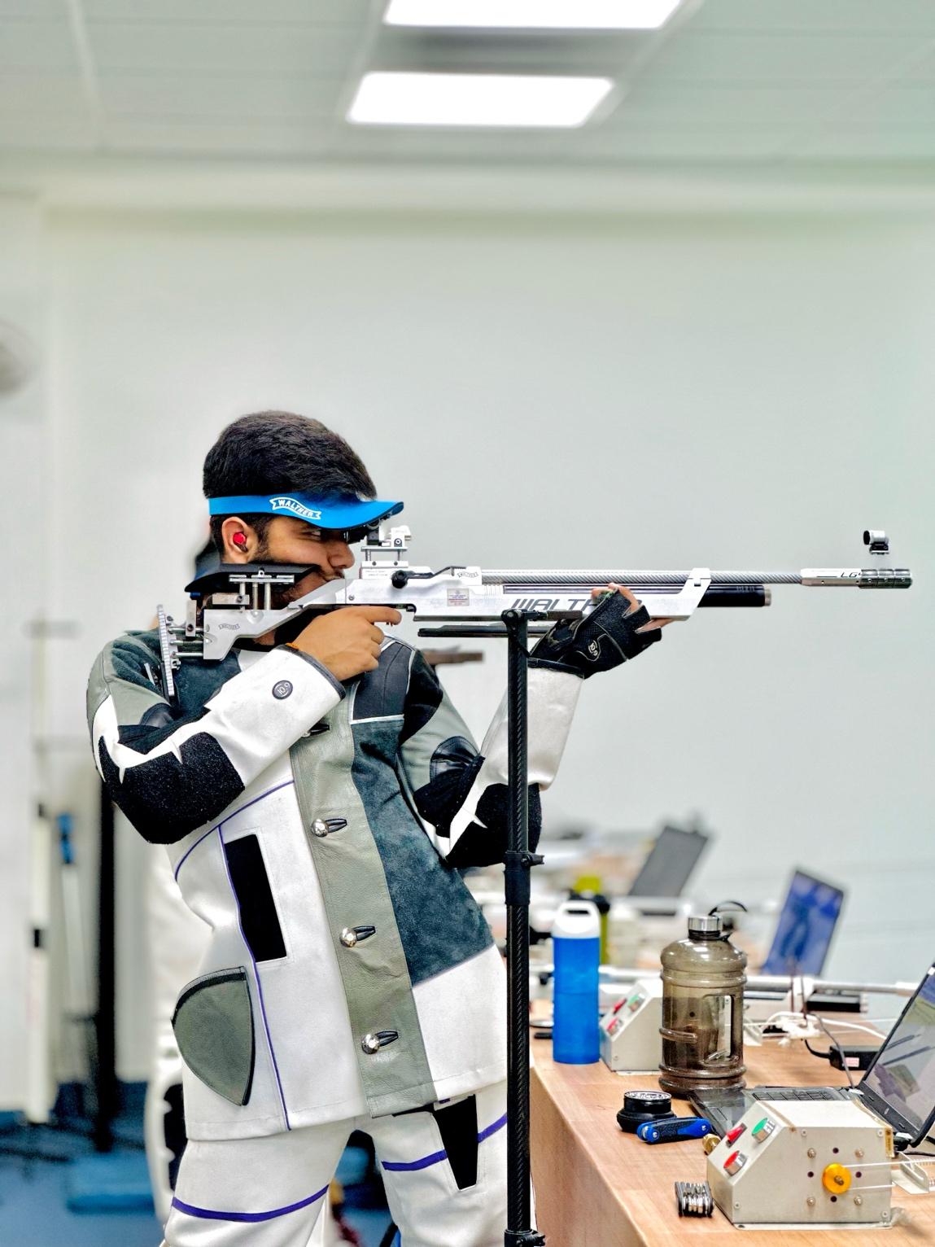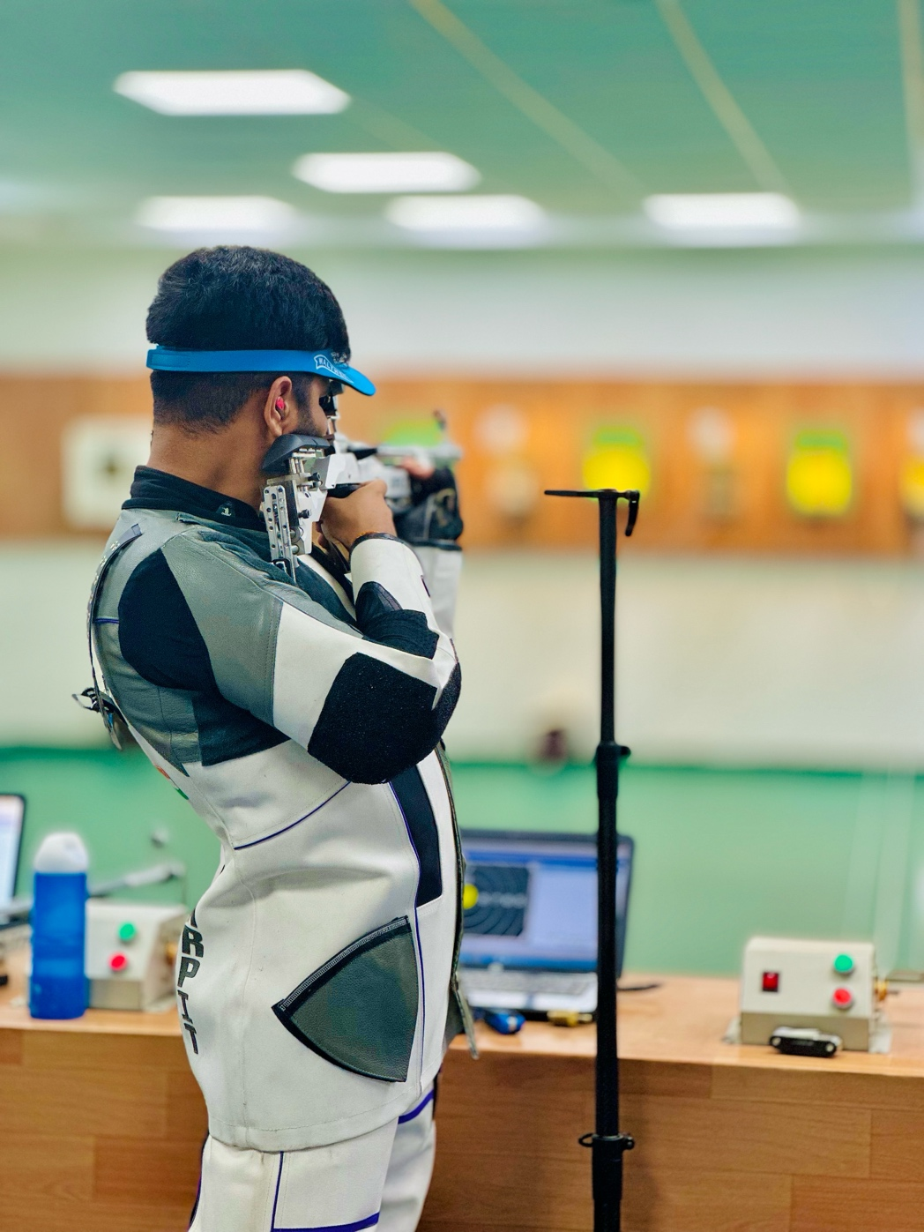
- Selected for Khelo India University
- North Zone University Championship
- Inter College Silver Medal in Individual Category
- All Indian University 9th Rank in Mixed Team
- All India University 11th Rank in the Mixed Team

Athletics (Men/Women)
Inter College, Selection Trials, Institutional Matches

Athletics for college students of Zakir Husain Delhi College Evening offers similar benefits as those in other universities and colleges. Our students show their interest in race, Javelin Throw, Shot Put, Long Jump and Sprint. Engaging in sports and physical activities particularly Athletics promotes overall well-being, reduces the risk of chronic diseases, and fosters healthy habits. Athletics provide opportunities for students to develop and enhance their physical skills, coordination, agility, and endurance.
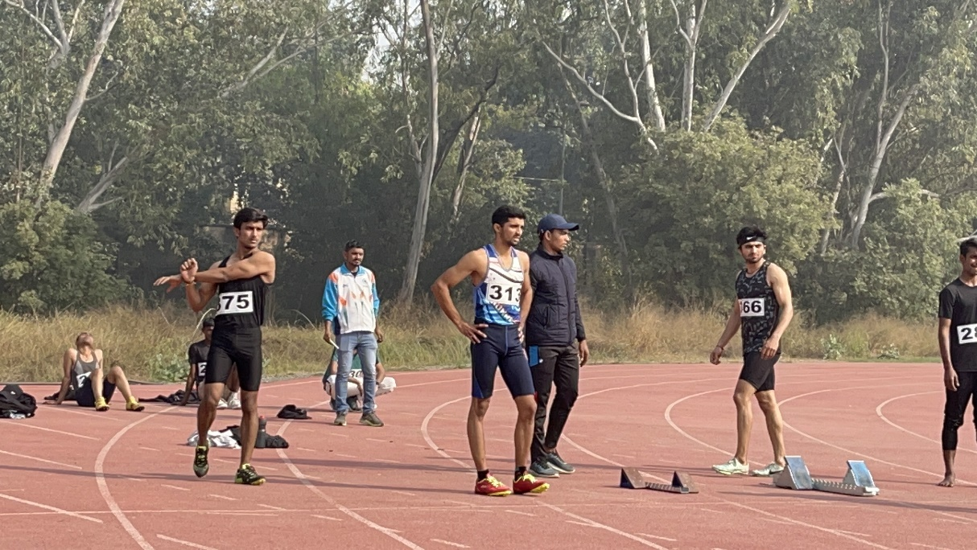

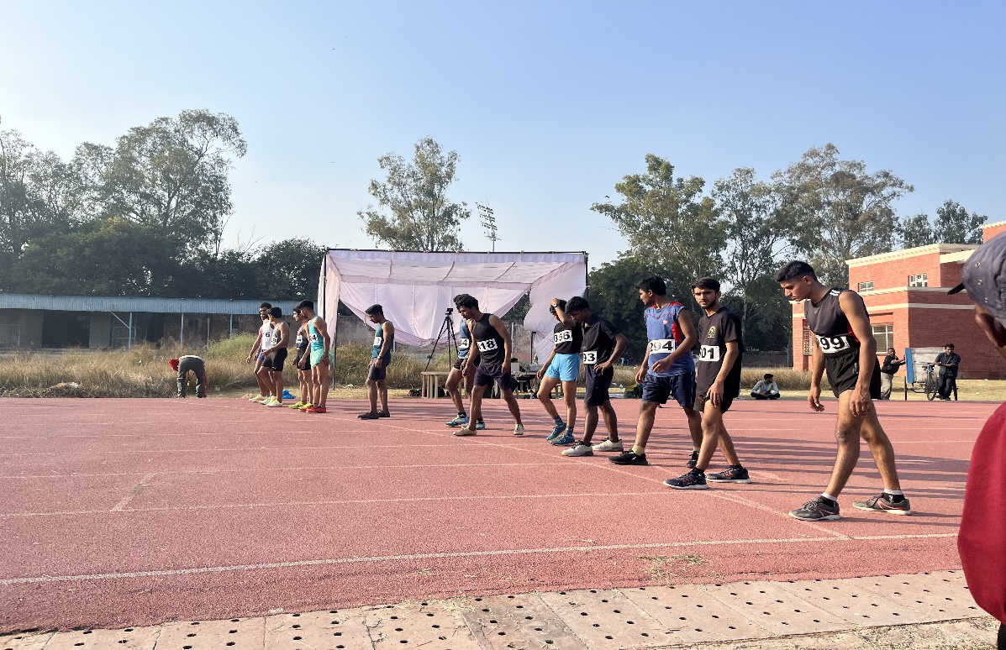

Students learn to work collaboratively with teammates, communicate effectively, and develop leadership qualities both on and off the field. Athletics offer Indian college students opportunities for personal growth and self-discovery. Through sports, students learn to overcome challenges, set and achieve goals, and build resilience.

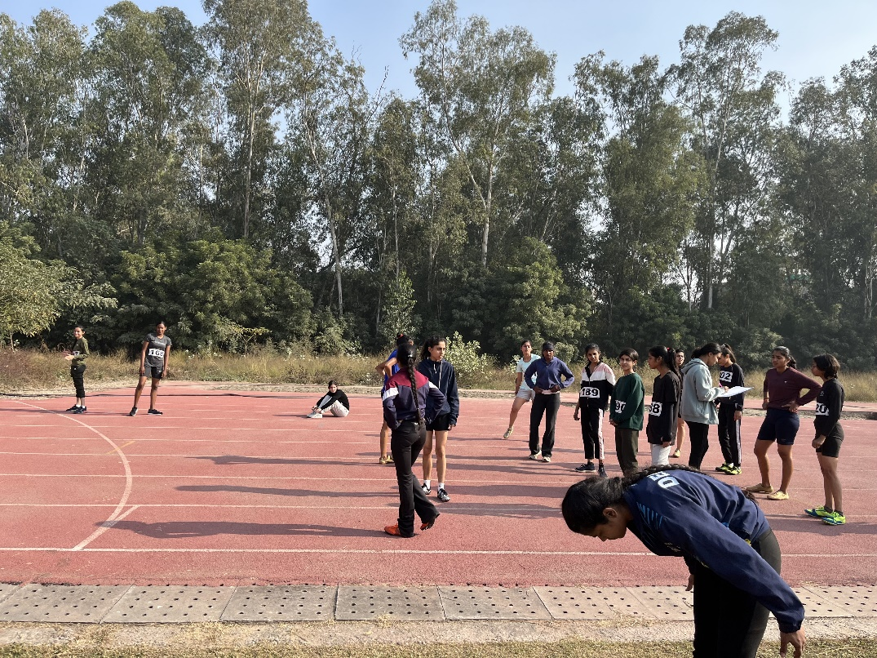

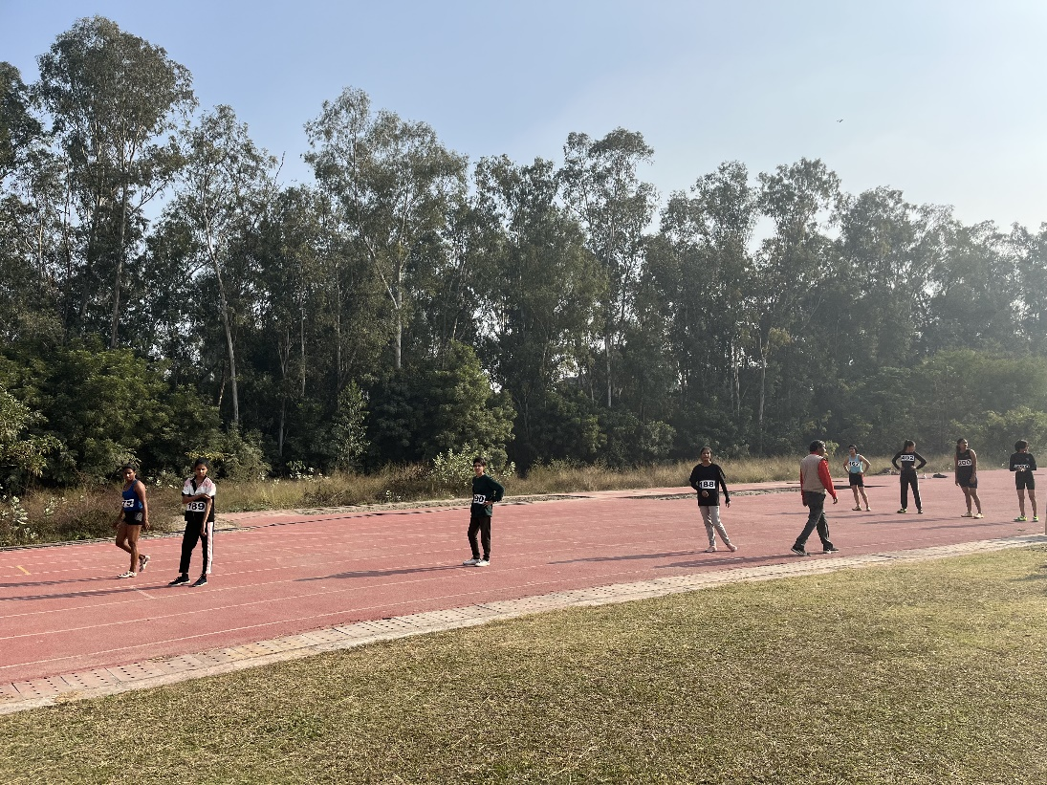
Girls Athletics Team participating in Inter College Athletics Championship organised by Delhi University Sports Council, University of Delhi

Shivam Arora (Athletics)

- Sri Ram College of Commerce – Shot Put -2nd Position, 2023
- Lady Sri Ram College for Women -Shot Put- 2nd Position 2023
- Maharaja Agrasen Institute of Technology -Badminton -Singles 3rd Position 2023
- Delhi Technological University –
- Shot Put -3rd Position 2023
- Discuss Throw- 3rd Position 2023
- Javelin Throw -3rd Position 2023
- Best Athlete Award

- Sri Ram College of Commerce – Shot Put -2nd Position 2024
- Lady Sri Ram College -Shot Put -1st Position 2024
- Zakir Husain Delhi College Evening
- Badminton Coordinator for WDC Badminton Event
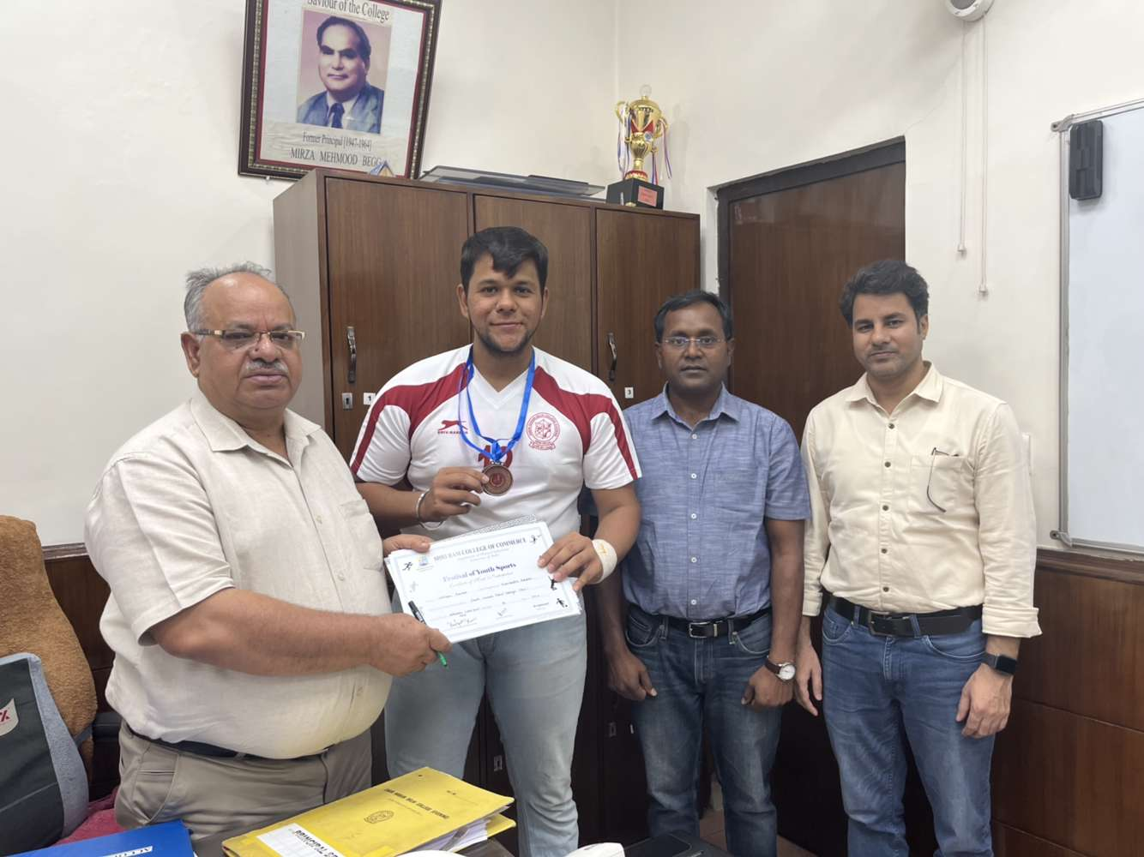

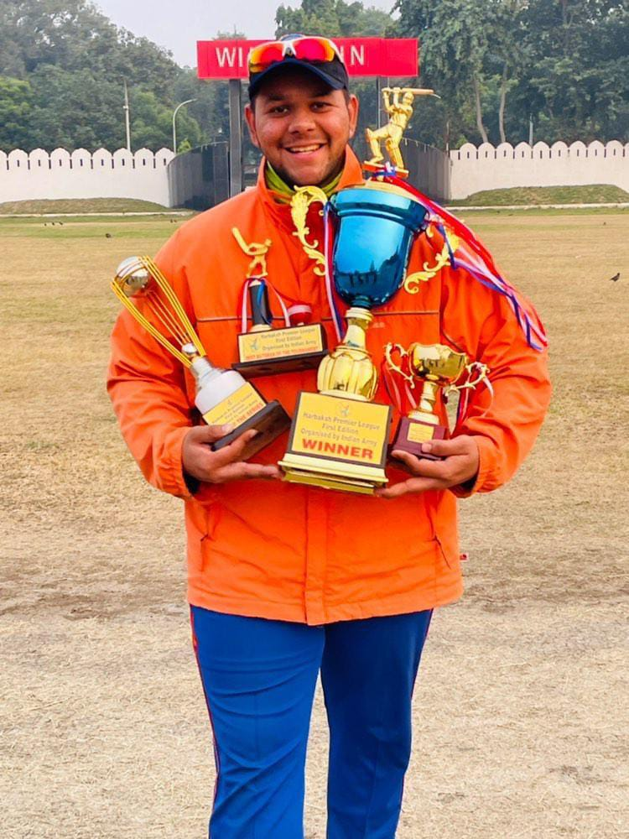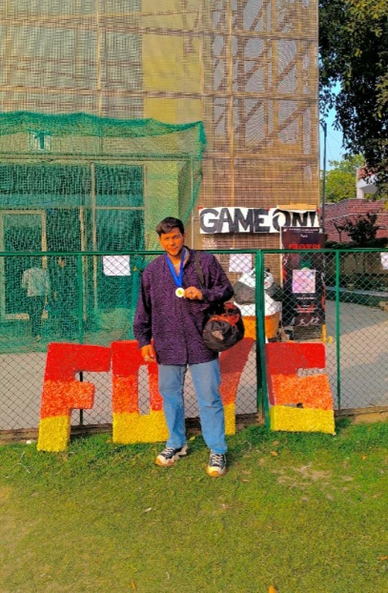

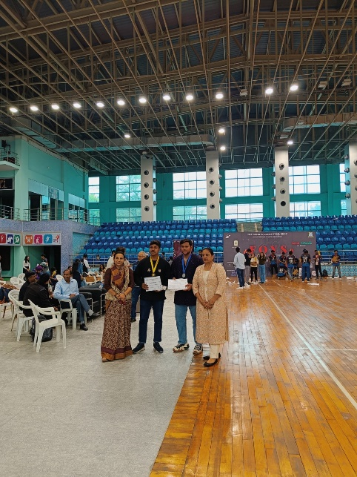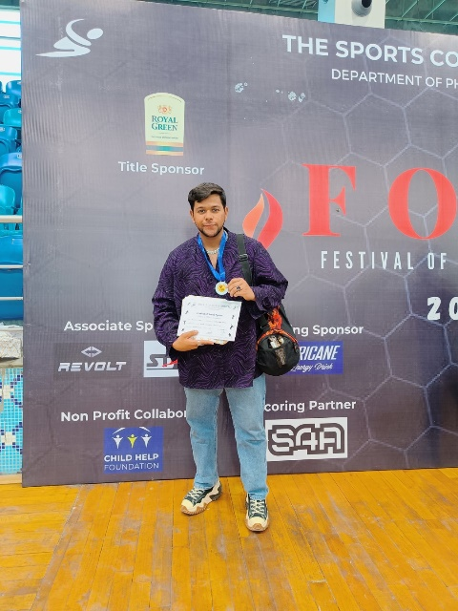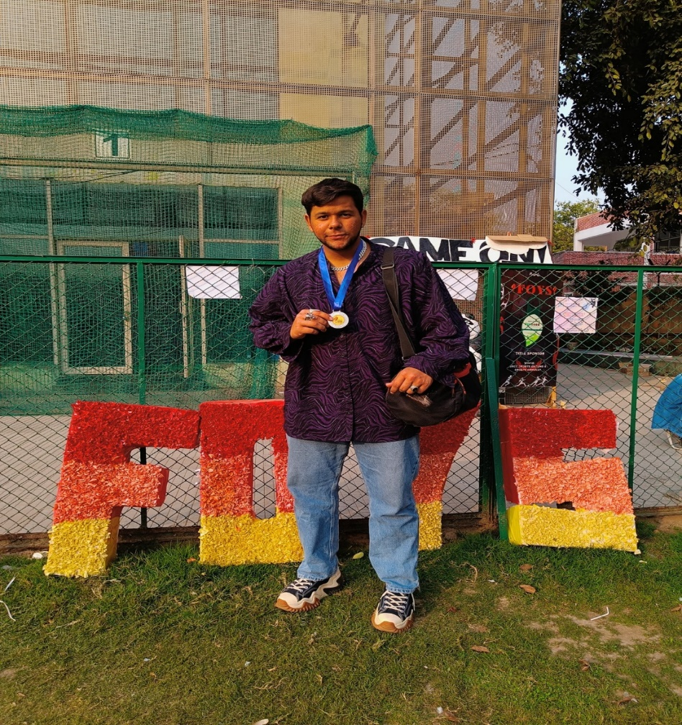
Medal won at SRCC Sports Festival

Wrestling (Men/Women)
Inter College, Selection Trials, Institutional Matches

Wrestling is a dynamic and ancient sport that embodies both physical prowess and strategic intelligence. Rooted in human history and culture, wrestling has evolved over centuries into various forms, each with its own rules, techniques, and traditions. Whether practiced as a competitive discipline, or a recreational activity, wrestling continues to captivate athletes and spectators alike with its intensity, grace, and complexity. Modern wrestling encompasses a variety of styles, each with its own rules and techniques. The most common styles include Freestyle Wrestling: This style is characterized by its dynamic and fast-paced nature, allows wrestlers to use both their arms and legs to execute takedowns, throws, and holds. Greco-Roman Wrestling emphasizes upper body strength and throws executed from the clinch. Folk style Wrestling is popular in the United States, Sumo Wrestling known as rikishi, attempt to force each other out of a circular ring or to the ground. Since the free Style Wrestling is popular in the Indian subcontinent, hence, it receives wider response and considered to be a popular form of wrestling.

Training typically includes cardiovascular exercises, strength training, and flexibility drills to improve their overall fitness and endurance. Wrestlers learn to overcome adversity, stay composed under stress, and develop a winning mind-set. Whether practiced for competition, recreation, or personal development, wrestling continues to inspire athletes of all ages and backgrounds to strive for excellence and reach their full potential. Zakir Husain Delhi College Evening has participated in inter college wrestling tournament and Inter University wrestling championship.

- The wrestling team of our college passionately participated in the Inter College Wrestling Championship organised by the Delhi University Sports Council at Virendra Sports and Education Academy (Wrestling) on 07.11.2023. Our students displayed their best wrestling skills and received appreciation.

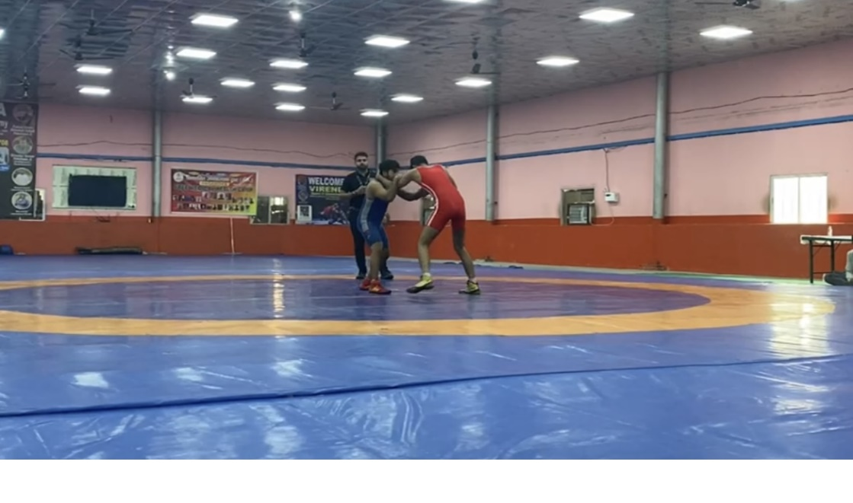
Students participating in Delhi University Inter College Wrestling Championship, 2023
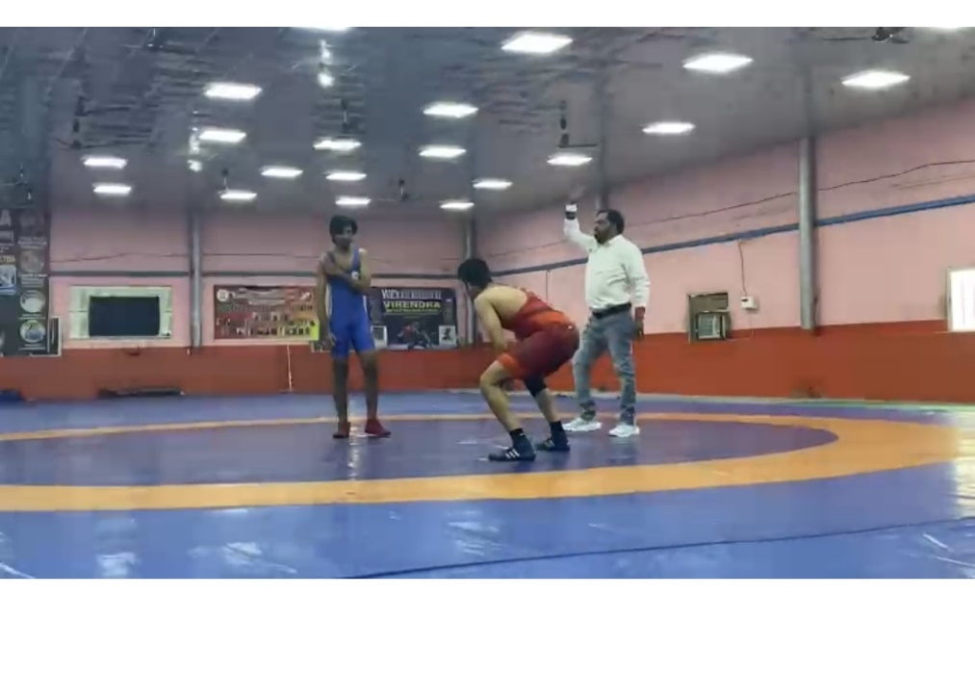
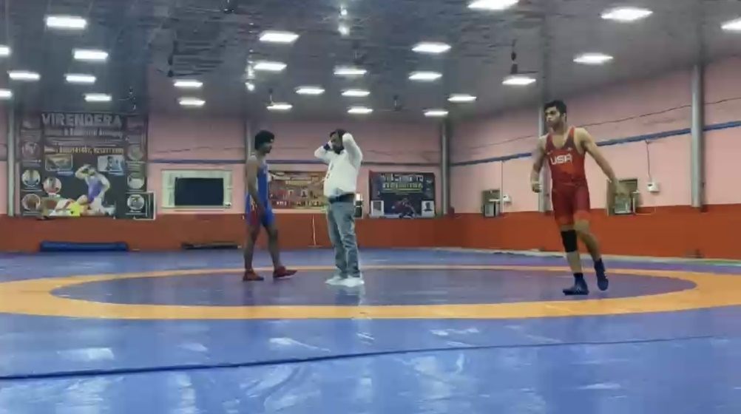

Student Wrestler participating in Inter College Championship, University of Delhi

Archery (Men)
Inter University, Inter College, Selection Trials

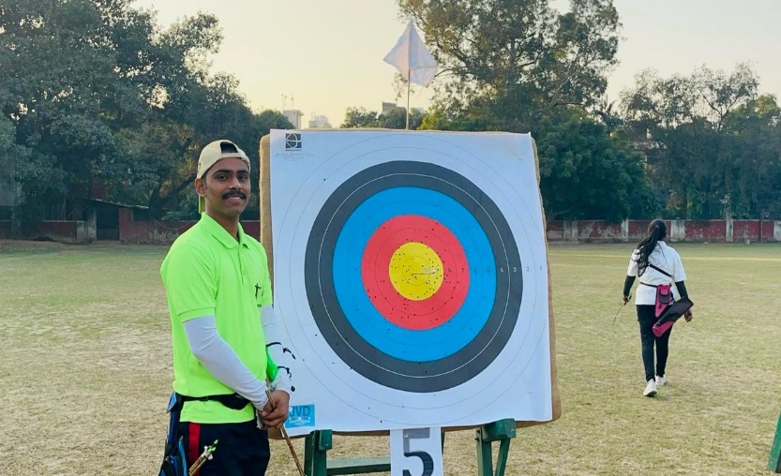
Inter University Selection Trials, University of Delhi
F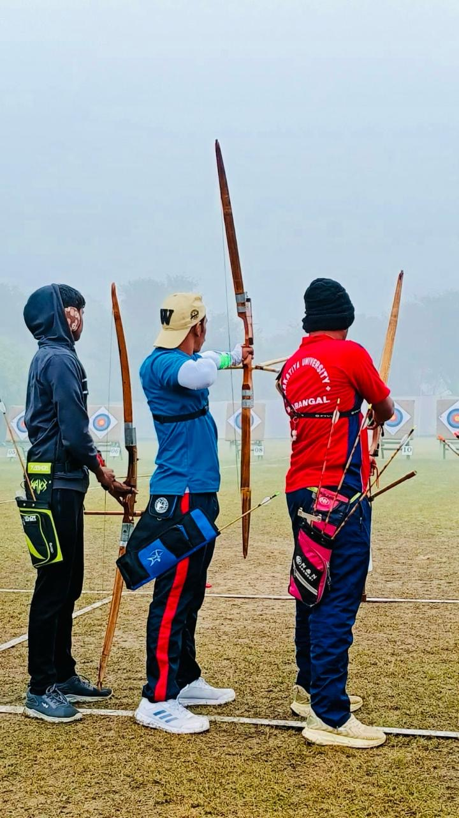
Inter University Match at Bhatinda
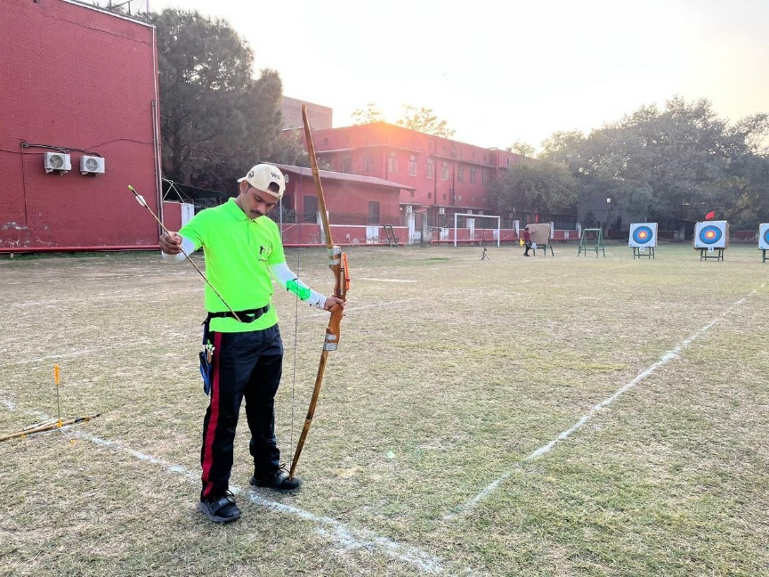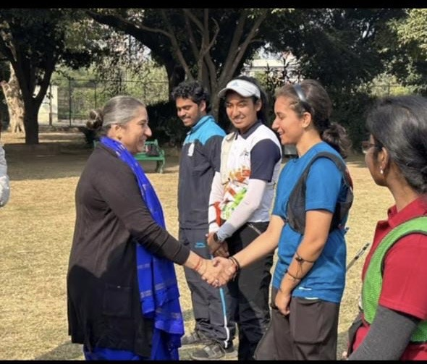
Inter University Match, Bhatinda
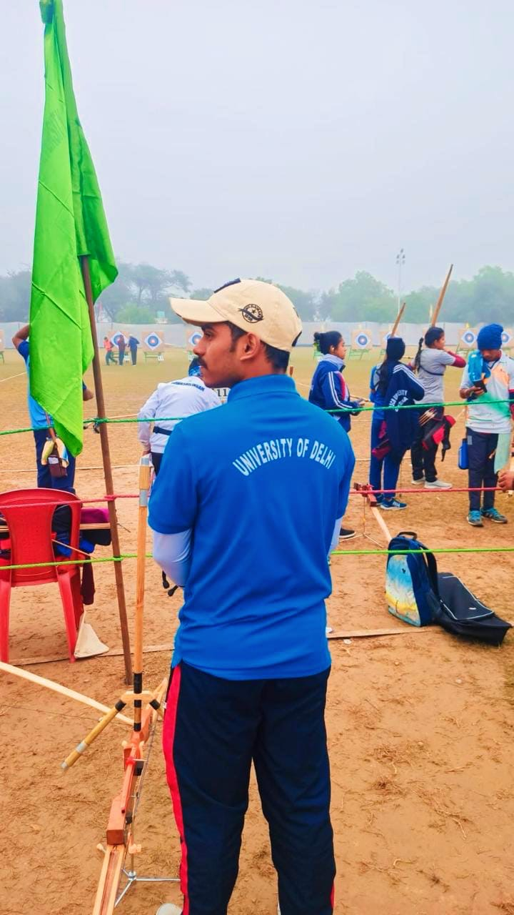
Inter University Match, Bhatinda

The Archery Championship is a prestigious event that brings together skilled archers from around the world to compete in various archery disciplines. University of Delhi also organises Archery Championship and all the College of Delhi University enthusiastically participate in this event. Zakir Husain Delhi College Evening participated in Inter University selection trials and represented the University in Inter University Championship. Our archer Prateek Gupta participated in the category of traditional form of archery where competitors use recurve bows to shoot arrows at targets from various distances. This event provided an opportunity for our archer to test his skills at the highest levels of competition and represent his college as well as the university on the national stage. Mr Prateek Gupta participated in the Inter College Archery championship and performed well.

Table Tennis (Men/Women)
Inter College, Selection Trials, Institutional Matches

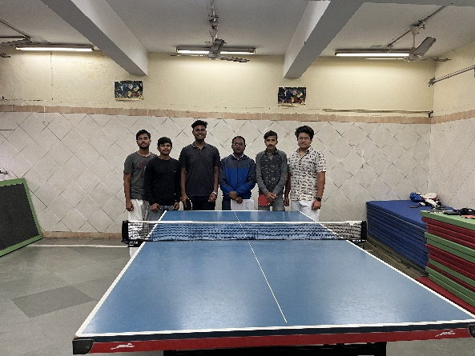

Table tennis can be played indoors, making it accessible year-round and regardless of weather conditions. Zakir Husain Delhi College Evening has table tennis facilities available for students to use either in recreational areas or as part of their athletic facilities. Regular play can help students stay physically active and improve their fitness levels, which is important for overall health and well-being. It provides an opportunity for students to socialize, meet new people, and build friendships outside of the classroom.
Table tennis provides a fun and engaging way for students to unwind, relieve stress, and take a break from their studies. Our college encourages the students to engage in practice sessions participate in intercollege tournaments conducted by the Delhi University Sports Council.
- Our college team participated in Inter College Table Tennis championship and received appreciation for their performance.

Squash (Men)
Inter College, Selection Trials, Inter University Matches

Squash is a dynamic and engaging racquet sport played professional sportsmen and college students. Our students has set record of participating in various national level Squash Championship as well as Intercollege championship organised by the Delhi University Sports Council. Doubtless to say that Squash is a physically demanding sport that provides an excellent cardiovascular workout and helps improve strength, agility, and endurance. Playing squash regularly can contribute to overall fitness. Squash requires a combination of technical skill and strategic thinking Ansh Tripathi represented Zakir Husain Delhi College Evening in intercollege and inter university games in the session 2023-24 and secured positions.

In the Session, 2024, Ansh Tripathi extensively participated and won in different categories

- Mr Ansh Tripathi represented our in intercollege as well as Inter University Squash Championship I the session 2023-2024 and won trophies and medals.
- He also participated in Khelo Indian scheme initiated by the government of India.
- In 2023, Mr Ansh Tripathi participated in the 37th National Games held in Goa from 1st Nov to 5th Nov 2023. He was a quarterfinalist in the game.

In the Session, 2024, Ansh Tripathi extensively participated and won in different categories

- Silver Medal in JSW Willington Tournament held on 13-17 January, 2024.
- Silver medal in Khelo India Youth Games held in Chennai on 20-24 January, 2024
- Gold Medal in 4th All India Brahmaputra Tournament held in Guwahati on 26-28 Janury, 2024.
- Silver medal in the 3rd Allahabad Tournament held on 9-12 February, 2024.
- Quarterfinalist in the All India Inter University Championship held in March 2024 at Somaiya College, Mumbai.

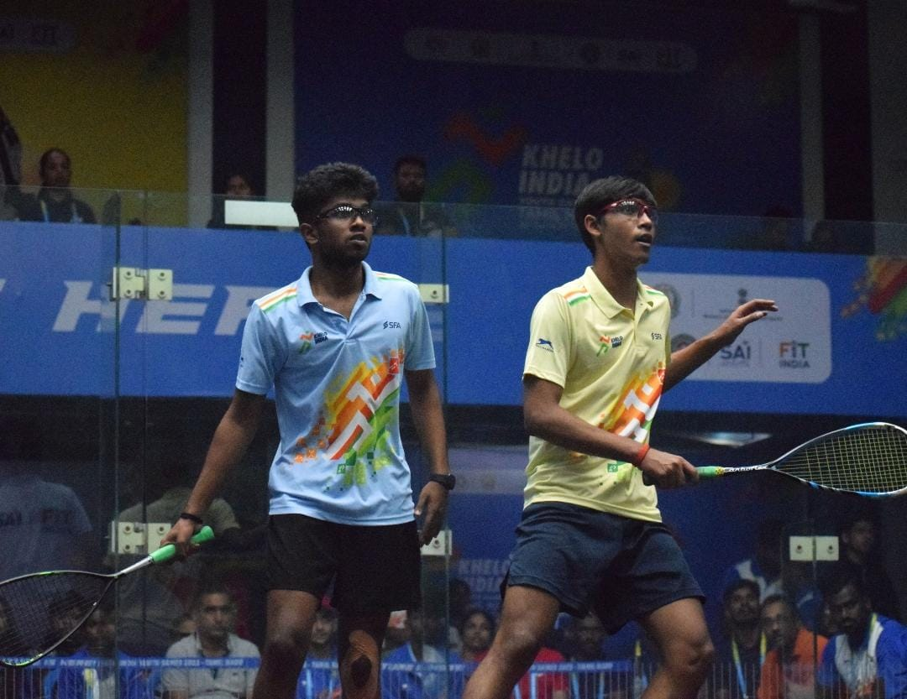
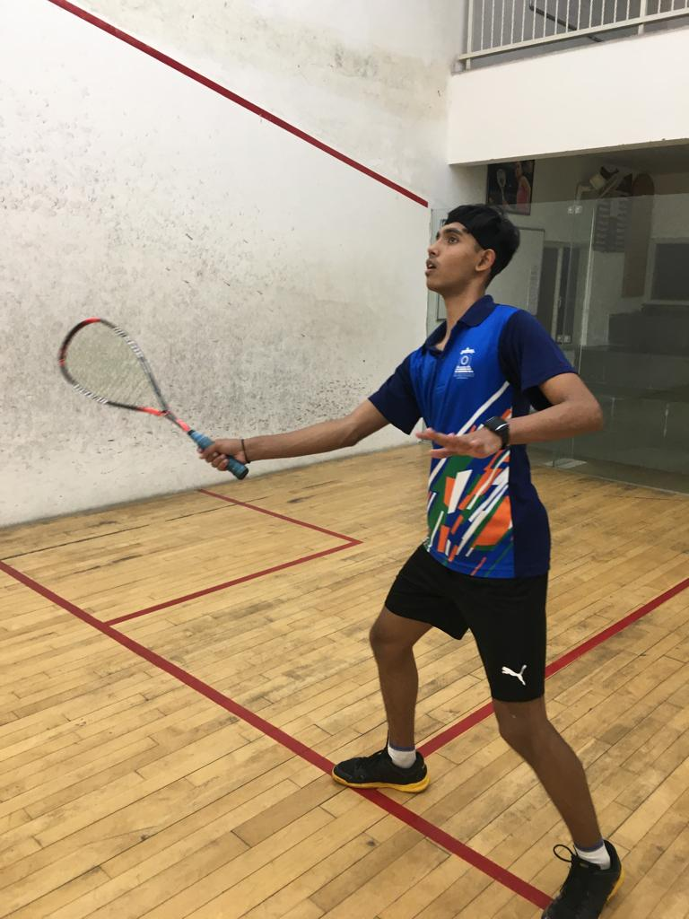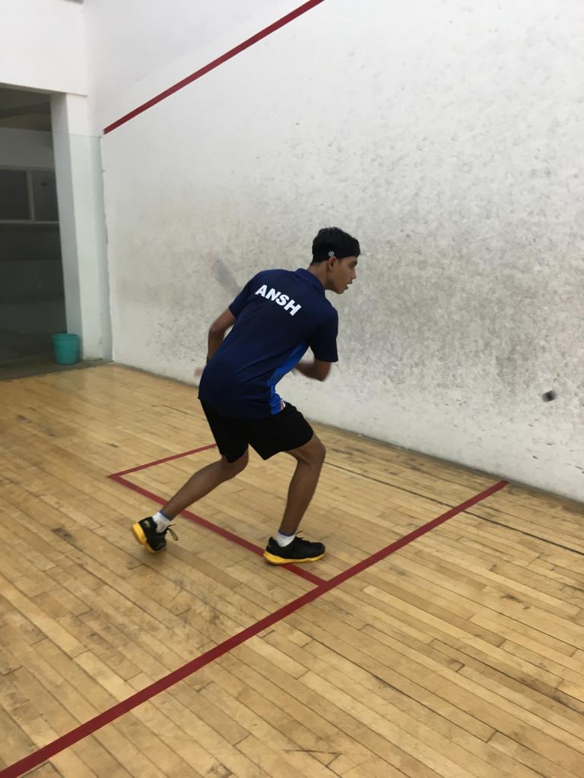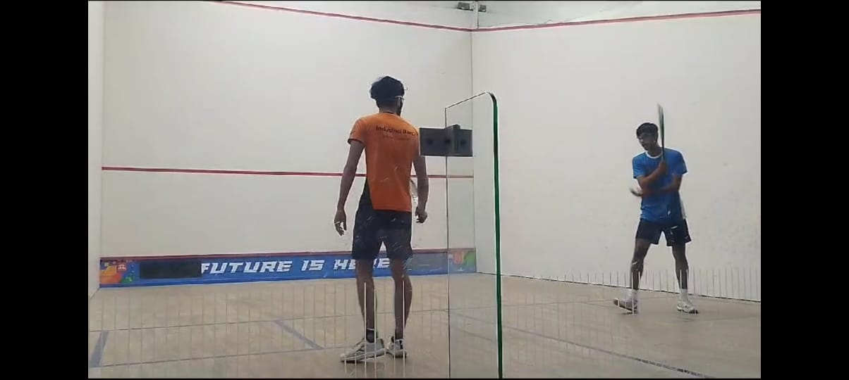
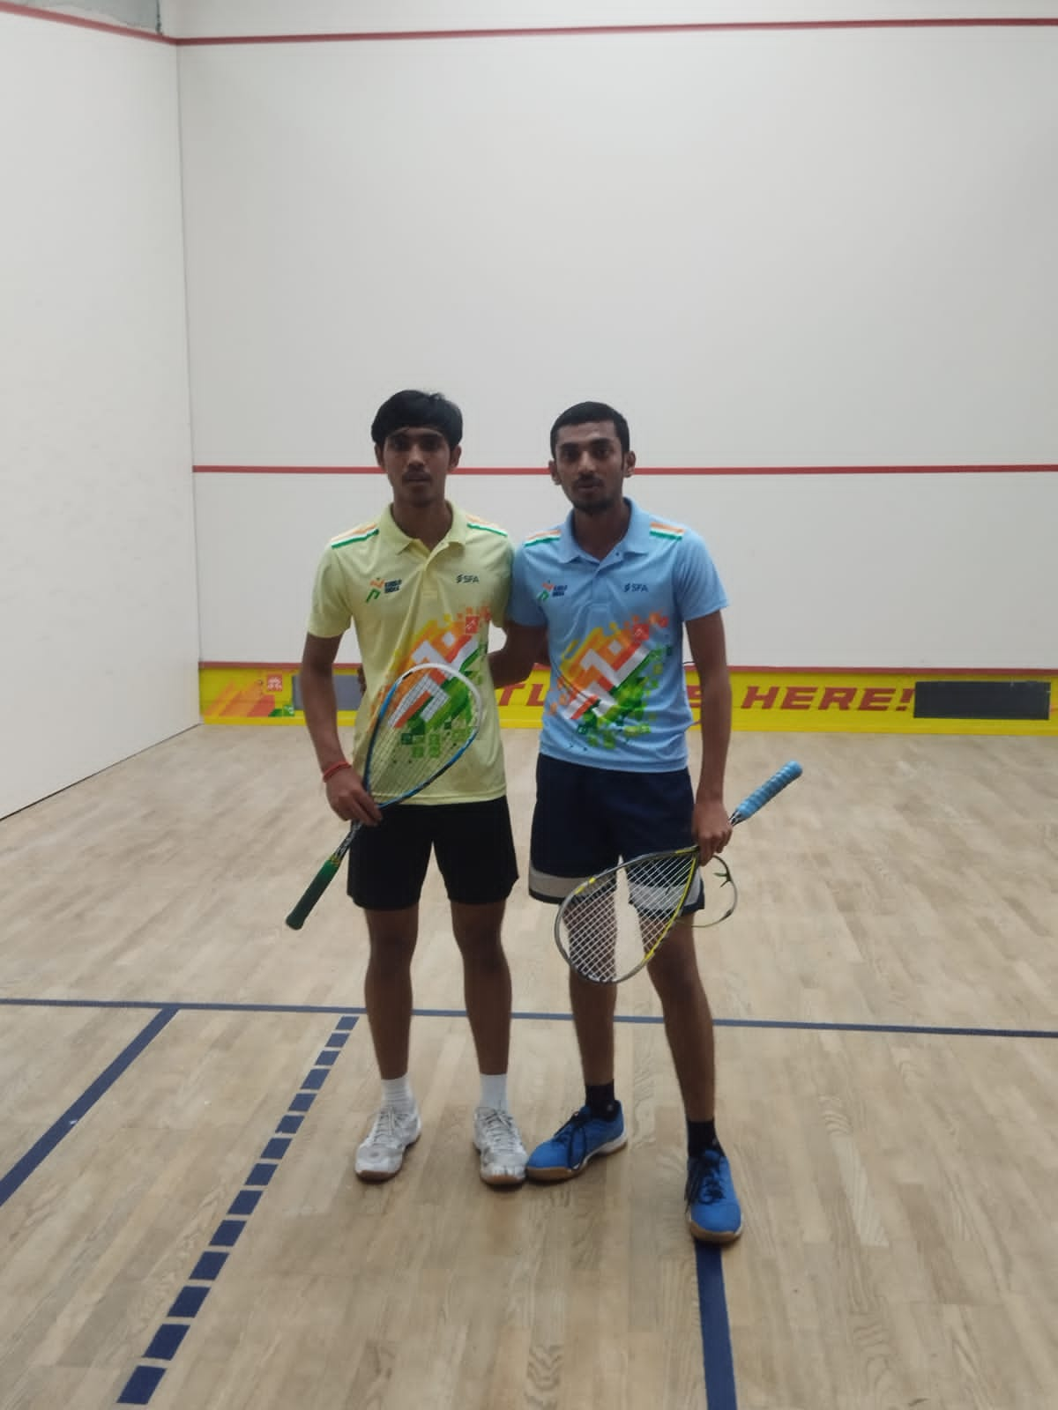

Participating in other institutional Sports festivals and Events 2023-2024
The student teams of our college participated in the following institutions like Amity University, ADGIPS, LSR, and SRCC sports events and gained appreciation for their outstanding performance.

Faculty Team Participation in sports Events
- Friendly Cricket Match at SGTB Khalsa College, New Delhi
- Shaheed Bhagat Singh Memorial Faculty Cricket Tournament
- Intra College Women Faculty Badminton Match, DHDCE
- Students’ Union Cricket Match, ZHDCE

